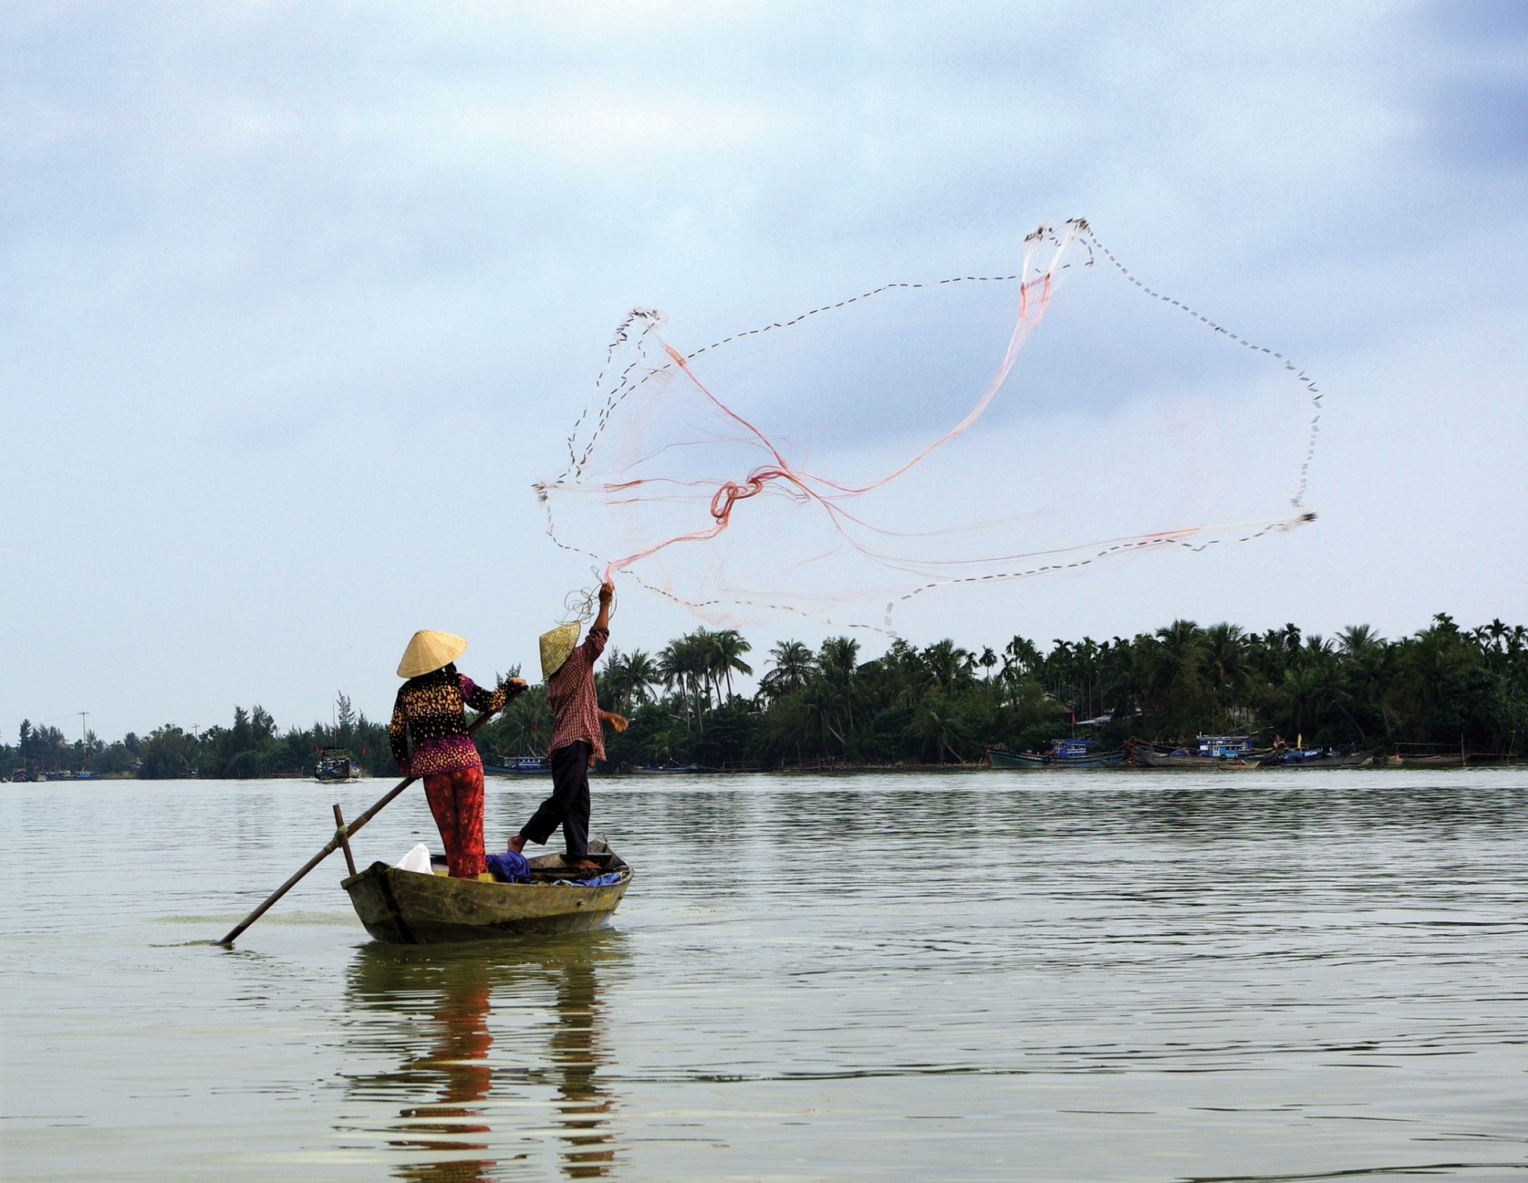

**Wednesday September 3, 2014 at 17.30**

The GWP Gender Strategy will bring gender into the mainstream of GWP’s work by providing a frame-work to practise gender- and women-inclusive approaches.

*GWP Booth (B01:21)*

*#watersecurity #waterandgender*

**Please come to the launch of GWP’s Gender Strategy and hear about our recent publications**

www**.gwp**.org

**Invitation**