Report title
Global Water Partnership (GWP), Global Secretariat, PO Box 24177, 104 51 Stockholm, SWEDEN
Phone: +46 (0)8 1213 8600, Email: gwp@gwp.org, Facebook.com/globalwaterpartnership, Twitter@gwpnews
Series title or type of document
www.gwp.org

Contents

Section 1: Heading Level 1 1
Sub Heading: Heading Level 2 1
Sub Heading: Heading Level 2 1
Sub Heading: Heading Level 2 1
Sub Heading: Heading Level 2 1
Sub Heading: Heading Level 2 2

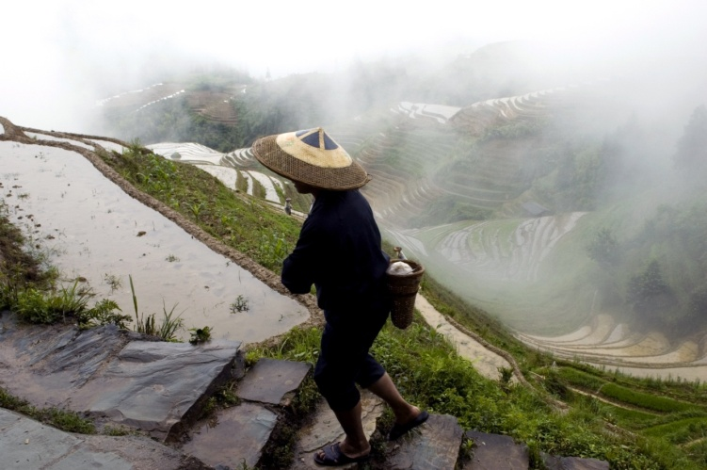
Section 1: Heading Level 1
These instructions have been inserted as marker text to help you to use this report template.

Sub Heading: Heading Level 2
To create new headings use the Heading Level buttons under Styles on the Home Tab. Simply type your heading or subheading, highlight it, and select the appropriate style (GWP Heading 1, 2, or 3), under the Home tab on the toolbar at the top of the page).
Box 1: Example
To insert a box like this, select the outside of this box (make sure the outline is a solid line). Then copy and paste it to wherever you would like to place a new box and insert your new content instead of this text. You can then drag and re-size the box as necessary.
- Example bullet
- Example bullet
- Example bullet
- Example bullet
- Example bullet
Photo 1: Caption
To update the Table of Contents, simply right click on it and choose “Update Field” and then “Update Entire Table”. This will then automatically add correct page numbers and any new headings (as long as they have been created using the heading styles described above).

Sub Heading: Heading Level 2
If at any point your body text appears in the wrong font (for example, when you have copied and pasted from another document), simply highlight the text with the wrong formatting and then choose the GWP Body Text style under the Home tab. This will convert the text to the default settings for this document.

Sub Heading: Heading Level 2
To insert a picture, go to the Insert tab and then choose Pictures. If your picture is not placing properly (i.e. if it is moving around in the text) click on it once (to highlight it) then right click it to bring up a drop down menu. In that menu choose Text Wrapping >Tight. This will allow you to drag the picture to any part of the page. To curve the edges of a picture, select the picture and go to the formatting tab. Click ‘Crop’ and then ‘Crop to Shape’. Then select the desired picture shape (‘rounded rectangle’ for curved edges).
- GWP Bulleted Text
- GWP Bulleted Text
- GWP Bulleted Text

Sub Heading: Heading Level 2
These instructions have been inserted as marker text to help you to use this report template.
To create new headings use the Heading Level buttons under Styles on the Home Tab. Simply type your heading or subheading, highlight it, and select the appropriate heading style (GWP Heading 1, 2, or 3), under the Home tab on the toolbar at the top of the page).
If at any point your body text appears in the wrong font (for example, when you have copied and pasted from another document), simply highlight the text with the wrong formatting and then choose the GWP Body Text style under the Home tab. This will convert the text to the default settings for this document.

Sub Heading: Heading Level 2
To insert a picture, go to the Insert tab and then choose Pictures. If your picture is not placing properly (i.e. if it is moving around in the text) click on it once (to highlight it) then right click it to bring up a drop down menu. In that menu choose Text Wrapping > Tight. This will allow you to drag the picture to any part of the page. To curve the edges of a picture, select the picture and go to the formatting tab. Click ‘Crop’ and then ‘Crop to Shape’. Then select the desired picture shape (‘rounded rectangle’ for curved edges).
- GWP Bulleted Text
- GWP Bulleted Text
- GWP Bulleted Text

Sub Heading: Heading Level 3
These instructions have been inserted as marker text to help you to use this report template.
To create new headings use the Heading Level buttons under Styles on the Home Tab. Simply type your heading or subheading, highlight it, and select the appropriate heading style (GWP Heading 1, 2, or 3), under the Home tab on the toolbar at the top of the page).
If at any point your body text appears in the wrong font (for example, when you have copied and pasted from another document), simply highlight the text with the wrong formatting and then choose the GWP Body Text style under the Home tab. This will convert the text to the default settings for this document.
To insert a picture, go to the Insert tab and then choose Pictures. If your picture is not placing properly (i.e. if it is moving around in the text) click on it once (to highlight it) then right click it to bring up a drop down menu. In that menu choose Text Wrapping > Tight. This will allow you to drag the picture to any part of the page. To curve the edges of a picture, select the picture and go to the formatting tab. Click ‘Crop’ and then ‘Crop to Shape’. Then select the desired picture shape (‘rounded rectangle’ for curved edges).

The Global Water Partnership’s vision is for a water secure world. Our mission is to advance governance and management of water resources for sustainable and equitable development.
www.gwp.org

