Drin Day 2016 Events
Organization Guidelines

What is the aim of the Drin Day events?
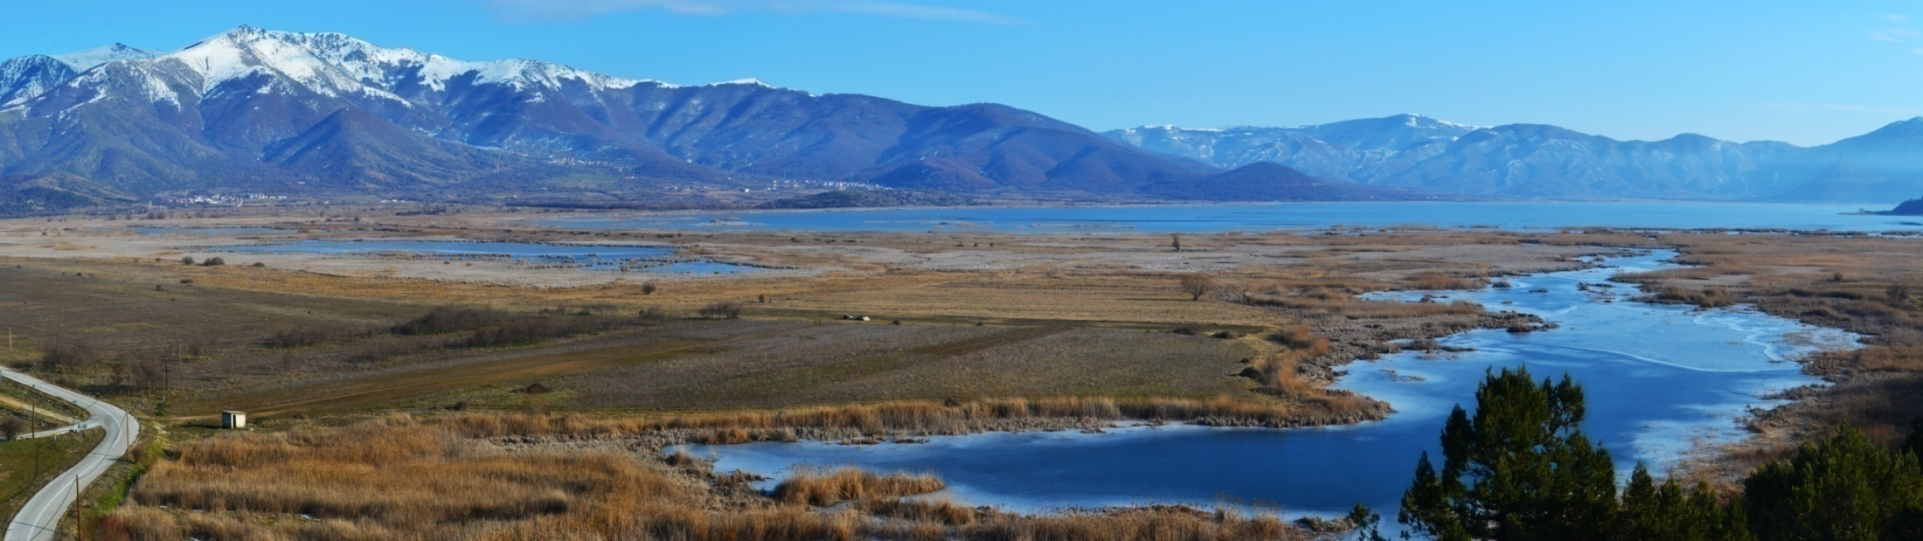
The overarching aim of the Drin Day events is to raise the awareness of local communities and the wider public on the importance of the sustainable management of the Drin River Basin and its freshwater ecosystems.
The events will enhance people’s awareness, and especially of youth, on the intrinsic values of freshwater habitats and species of the region. They will promote concrete, comprehensive and continuous actions towards safeguarding the biodiversity of the Drin River Basin and its invaluable ecosystem services.

Which are the key messages?
- The ‘Extended Drin River Basin’ is a unique water body connecting the people of the five Drin riparians – it is our common natural heritage.
- The intrinsic value of the Drin Basin is priceless – it is beyond doubt one of the most important biodiversity hotspots in Europe.
- Whether we realize it or not, freshwater ecosystems together with every bit of biodiversity they support and the ecosystem services they provide, determine our quality of life and wellbeing.
- Every action or ‘inaction’ along the Drin Basin affects us all.
- The protection of our natural common heritage cannot be left only to governments, treaties, top-down regulations and other similar approaches. We, as individuals can make the real difference by simply caring, respecting the right of all beings to enjoy this planet and by taking a holistic ‘life cycle’ view on life based on a sustainable consumption of resources. Don’t leave it only to governments – take charge – act now!

What type of event?
Each partner NGO will have the initiative and responsibility for the type and methodology used to conduct the event within the framework of the guidelines included herewith.
Some suggestions for the Drin Day events are:
- Organization of festivals with interactive workshops for children promoting the need to care for freshwater resources, both as a our natural/cultural heritage and and valueable for our future.
- Organization of an eco-products fair.
- Organization of field trips for groups of youths to the Drin River Basin, which could include cleanup actions, bird watching activities, freshwater ‘monitoring’, etc.
- Organization of a seminar/meeting with emphasis on ways to safeguard the biodiversity of the Drin River Basin and its invaluable ecosystem services.
- Organization of environmental exhibitions/competitions with pictures, videos, presentations, drawings and essays or projects implemented by students inspired by the Drin River, as well as theatrical performances.
Some suggestions for complementary activities are:
- Launching a survey to capture the views and perceptions of citizens living along the Drin River Basin on the key values and threats of the region and use the results as a mean to raise awareness.
- Combining the theme with activities (e.g. school visits) relating to Education for Sustainable Development, aiming to supply youth with simple tips on sustainable consumption behaviors in relation to the freshwater resources of the Drin River Basin.
- Launching an awareness raising campaign on social media making best use also of the project’s targeted tools (brochure, documentary, TV spots).

When should the event be organized?
The main/core event should be held on the 5th of May 2016 (Thursday) and should last at least for a half day. However complementary activities could be launched within the week of 1-7 May 2016.

Where should the event be organized?
The Drin Day events supported through this call should be organized in the local communities located along the Drin River Basin in the following Drin Riparians: Albania, Kosovo and the Former Yugoslav Republic of Macedonia. The Drin Day will be also celebrated in the Montenegrin part of the Drin Basin; related activities will be supported through a different process.

Target groups (and possible partners/collaborators)
The involvement of as many people and sectors as possible is a must. Therefore, the more and various the invitees are, the better. Also the presence of the media is strongly encouraged, as it will help not only the purpose of the event itself and disseminating the message but also the morale of the participants.
The event can be targeted to:
- local communities
- community based organizations
- educators & students
- various levels of public authorities
- transboundary bodies
- the media
- the wider public

Make sure that the activities promote gender equality!

Financial issues
An amount of 4000 $ is available as seed funding to support the organization of each selected NGO. The amount of 2500$ will be paid for labour costs, while the amount of 1500$ for promotional costs. Eligible promotional costs include:
- costs for filming and/or broadcasting of the Drin Day events in order to enhance impact;
- costs for purchasing eco-promotional products giving out an environment protection related message such as a thermos to advocate against single use plastic bottles, bags made of organic cotton to replace single use plastic bags, binoculars for bird watching, solar usb phone chargers, etc.

Organizing sustainable Drin Day events: Give a large event a small footprint
A sustainable event is one that is designed, organized and implemented with a view to minimizing its ecological footprint and maximizing its positive impact on society. To reduce the general impacts of our events or their ecological footprint, we should therefore always consider the life cycle when we organize an event, in order to identify the points that will have a bigger negative impact on the environment.
Below are listed some useful tips that should be used wherever applicable in order to minimize the ecological footprint of our event to the extent possible.
Sustainability target | How
Reduce energy use and the resulting greenhouse gas emissions |  | - Select venues and accommodation that implement energy efficiency measures, comply with green building standards and/or use renewable energy sources.  - Choose locations and venues minimizing local and long-distance transportation needs for participants and products.  - Where long-distance travel is unavoidable, offset GHG emissions.  - Apply energy-saving office practices during the organisation and hosting of the event.
Reduce materials consumption and waste generation |  | - Minimize materials provided to participants and used by service providers (e.g. caterer, exhibitors), before, during and after the event.  - Avoid the use of disposable items, use pre-used/ recycled and reusable/recyclable products and reduce packaging needs to a minimum  - Separate and recycle waste where possible.
Reduce water use |  | - Select venues and accommodation that implement water conservation practices and use water-efficient appliances.  - Implement water-conscious measures such as avoid bottled water and re-filling glasses only upon request.
Reduce indirect environmental impacts on air, water and soil |  | - Minimize the need to transport food and other products and favour local organic food.  - Use products manufactured with or containing fewer harmful substances, such as chlorine-free paper and non-toxic cleaning products.
Increase the social benefits for all involved |  | - Involve local and regional level as much as possible by, for example, recruiting local people (social integration), supporting SMEs (catering, energy, cleaning, IT supply, family-run accommodation), and showcasing successful local projects.  - Contribute to the Sustainable Development Goals and the core ILO Conventions through compliance with labour standards, and requiring social integration (reducing unemployment), Fair Trade products and social criteria along the supply chain.  - Assure security and health aspects (e.g., noise level).

