APPLICATION FORM

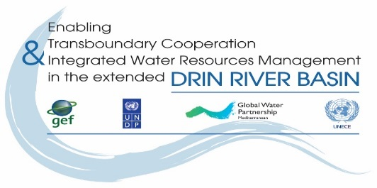
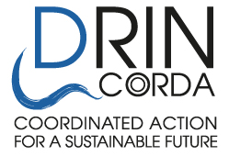

THE DRIN DAY CELEBRATION 2019

Expression of interest

- Name of NGO/CSO :__________________________

- Country: _______________________________________________________________________

- Drin Sub-basin the NGO is active/work at: _____________________________________________

- Our NGO would like to participate in the proposed activity

Name of person in charge: _____________________________________________
Address: _______________________________________________
Tel.: ___________________________________________________
Fax: ___________________________________________________
e-mail: _________________________________________________
web-site: _______________________________________________

- Title of proposed activity:

_______________________________________________________________________

- Description of proposed activity(s) (use max 2 pages):
_______________________________________________________________________________
________________________________________________________________________________
________________________________________________________________________________
________________________________________________________________________________
________________________________________________________________________________
________________________________________________________________________________

Date foreseen for the event to be held (Sunday , 5 May, 2019):
________________________________________________________________________________

The proposed activities as described above will be implemented with the following partner/ cooperating organization:

Partner/Cooperating NGO/CSO:
- Name of NGO/CSO:__________________________

- Country: _______________________________________________________________________

- Drin Sub-basin the NGO is active/work at: _____________________________________________

- Our NGO would like to participate in the proposed activity, as described above.

Signature: _______________________________________________________
Name of person in charge: _____________________________________________
Address: _______________________________________________
Tel.: ___________________________________________________
Fax: ___________________________________________________
e-mail: _________________________________________________
web-site: _______________________________________________

NOTE : You are obliged to prepare and send the detailed financial budget for the activities planned for the celebration of the Drin Day 2019, as an Annex to this Application form.

Having read and understood the attached Guidelines, I undertake the responsibility of organizing the event.

Signature: __________________________ Date: _______________________

Function in your NGO: ___________________________

This form must be sent by e-mail (dejan.panovski@gwpmed.org) to GWP-Med

