****

Strategy for flood and drought risk reduction and management

in the Volta Basin

and

its Action Plan (2023-2030)

June 2023

*(Final version for validation)*

**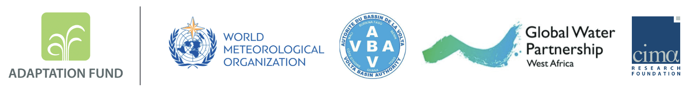**

**CONTENTS**

[FOREWORD 4](#_Toc141464523)

[ACKNOWLEDGMENT 6](#_Toc141464524)

[ACRONYMS 7](#_Toc141464525)

[SUMMARY 9](#_Toc141464526)

[CHAPTER 1 - Introduction 11](#_Toc141464527)

[1.1 Background 11](#_Toc141464528)

[1.2 Foundations of the strategy: international, regional and national disaster risk reduction framework (commitments and guidelines) 13](#_Toc141464529)

[1.3 Scope of the strategy 15](#_Toc141464530)

[CHAPTER 2 – Situational Analysis 18](#_Toc141464531)

[2.1. Climate, occurrence and impacts of floods and droughts 18](#_Toc141464532)

[2.2. Flood and Drought Risk Profile in the Volta Basin 20](#_Toc141464533)

[2.2.1. Estimation of the multisector impacts of floods and droughts 21](#_Toc141464534)

[2.2.2. Projections: impacts of climate and demographic change on flood and drought risks 22](#_Toc141464535)

[2.3 Flood and drought risk reduction in the Volta Basin: institutions and practices in place 24](#_Toc141464536)

[2.3.1. Regional organs and mechanisms for disaster risk reduction and management 24](#_Toc141464537)

[2.3.2. National organs and mechanisms for disaster risk reduction and management 27](#_Toc141464538)

[2.3.3. Early warning systems developed with support of regional and international stakeholders 29](#_Toc141464539)

[2.3.4. Early warning systems in place at national and local levels 30](#_Toc141464540)

[2.4 Issues, Challenges, Gaps and Opportunities for Integrated Flood and Drought Risk Reduction and Management in the Volta Basin 31](#_Toc141464541)

[CHAPTER 3 – Vision, objectives and strategic orientations 37](#_Toc141464542)

[3.1 Vision 37](#_Toc141464543)

[3.2 Objectives of the strategy 37](#_Toc141464544)

[3.3 Guidelines of the strategy 39](#_Toc141464545)

[3.4 Orientations of the strategy 39](#_Toc141464546)

[CHAPTER 4 – Means of implementation 42](#_Toc141464547)

[4.1 Roles of key stakeholders at different levels 42](#_Toc141464548)

[4.2 Cooperation and partnerships 44](#_Toc141464549)

[4.3 Resources mobilisation 47](#_Toc141464550)

[4.4 Monitoring and evaluation 48](#_Toc141464551)

[4.5 Learning and experiences’ sharing 48](#_Toc141464552)

[General conclusion 50](#_Toc141464553)

[Annexes 51](#_Toc141464554)

[Annex 1 - Action plan for the first 3 to 5 years of implementation of the Strategy 51](#_Toc141464555)

[Annex 2 - WMO criteria for the four categories of NMHSs 73](#_Toc141464556)

[Annex 3 - UNDRR Criteria for Progress Assessment 74](#_Toc141464557)

[Annex 4 – Volta Basin Flood and Drought Risk Profile 74](#_Toc141464558)

[Annex 5 - Clarification of key concepts 74](#_Toc141464559)

[REFERENCES 77](#_Toc141464560)

# FOREWORD

The Volta Basin Authority (VBA) is an intergovernmental organization, created on 19 January 2007 by the Heads of State and Government of the six (6) countries sharing the Volta River, its tributaries and sub-tributaries: Benin, Burkina Faso, Côte d'Ivoire, Ghana, Mali and Togo. With a length of 1850 km draining a hydrological basin of Côte d'Ivoire approximately 400,000 km², the transboundary nature of the Volta River was well understood by the VBA Member States, entrusting it with the Mandate to: "Promote permanent consultation and sustainable development for an equitable sharing of benefits with a view to poverty reduction and better socio-economic integration”.

However, the Volta Basin faces many environmental problems mainly due to the continued land, ecosystems degradation and water pollution. These phenomena are aggravated by episodes of droughts and floods that affect the whole basin and impact the economy and the livelihoods of the most vulnerable communities. The increase in the frequency and impacts of droughts and floods due to global and climatic changes are the subject of particular attention by the Volta Basin authorities.

The Volta Basin Authority worked with the CIMA Research Foundation, and with the support of the World Meteorological Organization and the Global Water Partnership - West Africa, to develop a strategy for the flood and drought risk management and reduction at the basin level and an action plan that lists concrete initiatives to achieve the targets by 2030. Based, among other things, on the data and scientific information of the risk profile and on the international guidelines, policies and good practices already in place, the strategy aims to address the major challenges identified for the flood and drought risk reduction in the Volta Basin. A series of actions is proposed for integration into the national planning of the six riparian countries, to be implemented in a coordinated manner between the various national stakeholders under the coordination of the VBA.

This strategy, as result of wide consultation, aims to meet the needs of communities at the basin level as a priority. It proposes concrete actions to better reduce the impacts and manage the present and future risks that threaten the basin population towards the increased floods and droughts.

The appropriation and operationalization of the strategy by all the stakeholders, including those who hold certain power of decision, leadership and mobilization of financing, are highly essential.

On the same subject, I hope that all national and international stakeholders can work in a synergistic and coordinated way for the implementation of the actions proposed in the action plan of this strategy to improve the resilience of our different communities.

I will end by emphasizing that the development, appropriation and operationalization of this strategy, as well as the various tools to strengthen knowledge of risks and early warning, by all the stakeholders concerned, constitutes one of the values of the VFDM project collaboratively implemented by the WMO-GWP/WA-VBA Consortium, an important project financed by the Adaptation Fund to which I reiterate our gratitude and our sincere thanks.

|  |  |
| --- | --- |
| D:\DOSSIERS_Perso_DES-Rob\PHOTO DE\IMG_1174.JPG | **DESSOUASSI Yaovi Robert**  **Executive Director of the Volta Basin Authority (VBA)** |

# ACKNOWLEDGMENTS

This strategy is the result of in-depth research and close collaboration between the Government institutions of the Volta Basin riparian countries, and international organizations including CIMA Research Foundation. This document has been developed as part of the implementation of the project “Integrating Flood and Drought Management and Early Warning for Climate Change Adaptation in the Volta Basin” (VFDM project), financed by the Adaptation Fund. It follows and is based, among other things, on the results of the risk profile associated with floods and droughts in the basin, developed last year during the same VFDM project.

CIMA Foundation would like to thank and highlight the valuable support of all the project partners, namely: the World Meteorological Organization, the Global Water Partnership West Africa, the Volta Basin Authority and its National Focal Structures, especially the Water Resources Commission of Ghana, the General Directorate of Water Resources of Burkina Faso, the Directorate of Water Resources of Togo, the General Directorate of Water of Benin, the Directorate of Protection and Management of Water Resources in Côte d'Ivoire and the National Directorate of Hydraulics in Mali.

This strategy not only represents the synthesis of the information acquired from the analysis of the risks of floods and droughts, as well as the reduction of these risks in the Volta basin, but it is also the result of the mobilization of different national stakeholders through six consultation and co-development workshops. The contributions and comments provided by the national experts of the six riparian countries engaged in the process of co-elaboration of the strategy and the local institutions have, once again, highlighted the importance of fruitful collaborative relationships for sharing knowledge and advancement towards effective disaster risk reduction and improved resilience of communities in the Volta Basin.

# ACRONYMS

|  |  |
| --- | --- |
| ACMAD | African Centre for Meteorological Applications for Development |
| ACP-UE | Africa, Caribbean and Pacific and European Union Cooperation |
| AFD | French Development Agency |
| ARC | African Risk Capacity |
| ASECNA | Agency for Air Navigation Safety in Africa and Madagascar |
| AU | African Union |
| CCA | Climate Change Adaptation |
| CCR-AOS | Regional Climate Centre for West Africa and the Sahel |
| CILSS | Permanent Inter-State Committee for Drought Control in the Sahel |
| CIMA | International Centre for Environmental Monitoring |
| COP | Conference of Parties |
| CSO | Civil Society Organization |
| CTCN | Climate Technology Centre and Network |
| DE-VBA | Executive Directorate of the Volta Basin Authority |
| DHI | Danish Hydraulic Institute |
| DRR | Disaster Risk Reduction |
| ECOWAS | Economic Community of West African States |
| EWS | Early Warning Systems |
| FEWS | Flood Early Warning System |
| FTP | Financial Technical Partners |
| GEF | Global Environment Facility/Fonds pour l’Environnement Mondial |
| GFDRR | Global Facility for Disaster Reduction and Recovery |
| GGW | Great Green Wall |
| GWP-WA | Global Water Partnership – West Africa |
| HKV | Dutch consulting company |
| IDID | Initiatives for integrated and sustainable development |
| IPCC | Intergovernmental Panel on Climate Change |
| ISDR | International Strategy for Disaster Reduction |
| IUCN | International Union for Conservation of Nature |
| IWA | International Water Association |
| IWRM | Integrated Water Resources Management |
| MOLOA | West African Coastal Observation Mission |
| NDCs | Nationally Determined Contributions |
| NDRR | National Disaster Risk Reduction |
| NFS | National Focal Structures |
| NGO | Non-Governmental Organization |
| NMHS | National Meteorological and Hydrological Services |
| NPDRR | National Platform for Disaster Risk Reduction |
| OPIDIN | Forecast tool to predict the inundations in the Inner Niger Delta |
| RCP | Representative Concentration Pathways |
| RCS | Regional Climate Strategy |
| RSMC | Regional Specialized Meteorological Centre |
| SDAGE | Water development and management plan |
| SDGs | Sustainable Development Goals |
| UN | United Nations |
| UNDP | United Nations Development Program |
| UNDRR | United Nations Office for Disaster Risk Reduction |
| UNECA | United Nations Economic Commission for Africa |
| UNEP | United Nations Environment Program |
| USD | United States dollars |
| VBA | Volta Basin Authority |
| VFDM | Integrating Flood and Drought Management and Early Warning for Climate Change Adaptation in the Volta Basin" Project |
| WAEMU | West African Economic and Monetary Union (also known by its French acronym UEMOA) |
| WASCAL | West African Science Service Centre on Climate Change and Adapted Land Use |
| WFP | World Food Program |
| WMO | World Meteorological Organization |

# SUMMARY

This strategy is part of the project "Integrating Flood and Drought Management and Early Warning for Climate Change Adaptation in the Volta Basin" (VFDM project), implemented by the World Meteorological Organization (WMO), the Volta Basin Authority (VBA) and the Global Water Partnership West Africa (GWP-WA) Consortium.

This strategy is the result of an inclusive process, involving the participation of all DRR stakeholders present in the six countries, and with the technical support of CIMA Foundation.

This strategy, arising from the analysis of the current situation in terms of flood and drought risk management and from the related issues and challenges, responds to the need to deal in a common way with the threats linked to floods and droughts in the Volta Basin. It provides States Parties with a framework and guidelines for improving and harmonizing the approaches and instruments in place for integrated and transboundary flood and drought risk management, based on four main guidelines:

* Establishing a better understanding of flood and drought risks;
* Improving governance for integrated and transboundary flood and drought risk management in the basin;
* Coordinating the implementation of integrated flood and drought risk reduction measures for the resilience of people and ecosystems;
* Establishing protocols for anticipatory actions and decision support based on climate, weather and hydrological forecasts.

An overview of the threats related to floods and droughts faced by population in the geographical, hydro-climatic and economic context of the Volta Basin is presented in the **first introductory chapter**, along with the international, regional and national strategic frameworks in which this strategy is embedded. The key points from the analysis of flood and drought risks in the Volta basin are summarized in **the second chapter** through a diagnosis of the climate and the occurrences and impacts of floods and droughts. It also includes a summary of the results of the flood and drought risks profile under current climatic conditions, followed by future projections. The analysis is completed by a presentation of the institutional and political framework in place for flood and drought risk reduction and management at the basin scale, followed by an analysis of the main stakes, challenges, gaps and opportunities for integrated risk management. The content of the strategy is presented in **the third chapter.** Adopted by the six States Parties, the vision of the regional strategy for flood and drought risk reduction and management in the Volta Basin is such that: “*By 2030, the Volta Basin has operational mechanisms (institutional, legislative and financial) for concerted and integrated flood and drought risk management, ensuring community resilience to climate change, sustainable and inclusive socio-economic development, as well as protection of ecosystems and optimization of water resources.*” To achieve a common general objective, the stakeholders defined and agreed on four strategic axes for which an action plan was developed (Annex 1). **The last chapter** details the means for implementing the strategy, in particular by elaborating on the role of the stakeholders, the opportunities for partnerships and the strategies for mobilizing the financing essential to the realization of this strategy. Finally, the need to plan activities for monitoring, evaluation and learning from activities is highlighted as critical to the successful implementation of the strategy to the successful of the implementation of the Strategy.

# CHAPTER 1 - Introduction

This introductory chapter presents the flood and drought risks in their geographical, hydro-climatic and economic context, specific to the Volta basin. It clarifies the international, regional and national strategic frameworks within which this disaster risk reduction strategy is embedded, and outlines the scope of the document.

## 1.1 Background

Over the past four decades, sub-Saharan Africa has experienced more than 1,000 hydro-meteorological disasters (World Bank, 2017), affecting around 320 million people. In addition to the loss of lives and the displacement of populations, episodes of drought and flooding have major economic impacts and jeopardize food security and the socio-economic development of countries.

Indeed, rainfall in West Africa is intensifying and becoming rarer at the same time, and varies in space and time, creating devastating rainfall events, and a variation in rainfall in space and time responsible for drought episodes both regionally and locally. Climate projections for West Africa indicate that this situation could be exacerbated in the future climate due to the upward trend in climate parameters, which could lead to the amplification of the impact of disasters in a context of population growth and pressure on natural resources and particularly on water resources.

In this context of increasing flood and drought risks, disaster risk management has become essential for national and regional policies. It requires the strengthening of early warning systems, the adaptation of agricultural practices according to hydro-climatic forecasts, the establishment of adequate infrastructure and appropriate land-use planning guidelines, and finally the strengthening of the capacities of institutions mandated to reduce disaster risks at the national and regional levels. However, the appropriate scale for understanding and managing water resources and the impacts of hydro-meteorological phenomena in an integrated manner remains at the basin level. Further, there is the need to appreciate the hydrological interdependence of countries and communities in the upstream and downstream context of the basin.

The transboundary Volta basin, shared by Benin, Burkina Faso, Côte d'Ivoire, Ghana, Mali and Togo, is particularly vulnerable to climatic extremes such as floods and droughts. Every year its population is affected by both recurrent droughts and floods in rural and urban areas. The most extreme climatic episodes (such as the floods of 2010, 2019 and 2020 and the drought of 2012) affected hundreds of thousands of people in the basin. In addition to irregularity in the distribution and intensity of rainfall, the basin faces rising temperatures, soil erosion and desertification. These climate issues are at the heart of the fight against poverty in the region. Indeed, facing economic, environmental, and water management challenges, the six riparian States remain constrained by poor national economic performance and a low human development index[[1]](#footnote-2) compared to the global context, varying between 0.428 and 0.632 in 2022 (UNDP, 2022; UNDP, 2019; World Bank, 2019).

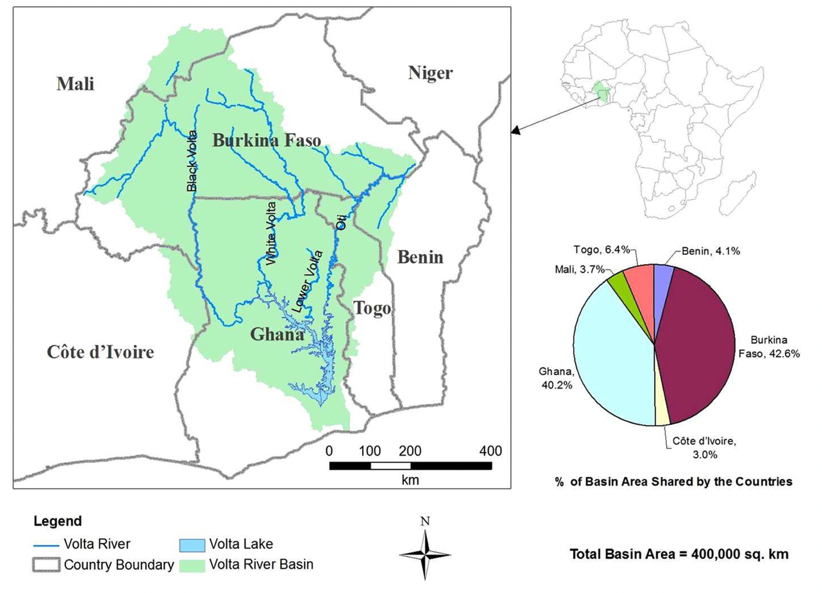*Figure 1. Map of the Volta transboundary basin (JULIUS H.K. ET AL, 2017)*

The Volta Basin covers an area of ​​approximately 400,000 km², making it the ninth largest basin in sub-Saharan Africa (VBA, 2010). The population of the basin, estimated at around 29 million in 2020 and increasing to 59 million in 2050 (UN, 2022), is essentially rural and depends mainly on rain-fed agriculture and natural resources (GEF-UNEP -DHI-IWA, 2017). However, 30% of the population of the basin is concentrated in urban areas (around Ouagadougou, Bobo-Dioulasso in Burkina Faso, Tamale, Wa and Bolgatanga in Ghana and in the Kara region in Togo).

The Volta river, with a length of 1,850 km, traverses Burkina Faso into Ghana, at an average flow of 1,210 m3/s to the estuary into the Gulf of Guinea. The Volta basin, which spans the semi-arid to sub-humid zones, is characterized by a north-south gradient in the distribution of rainfall, with high variability in time and space, high evapotranspiration, and river flow that is extremely sensitive to variations in rainfall, having an impact on agriculture and hydropower production (Lemoalle, J. and De Condappa, D., 2009).

Concerning the vulnerability of the Volta basin to climate shocks, there was a general consensus between the stakeholders to prioritize flood and drought management in policies, programs and development projects in the basin. This approach involves, among other things, the development and implementation of this strategy together with the action plan for the integrated management of droughts and floods at the national and transboundary levels of the basin.

## 1.2 Foundations of the strategy: international, regional and national disaster risk reduction framework (commitments and guidelines)

The regional strategy for flood and drought risks reduction and management in the Volta Basin is part of the efforts of the international Community as well as regional institutions and States of the Volta Basin to promote disaster risk reduction (DRR). These efforts are based on the following three main multilateral agreements on the environment and sustainable development, adopted by the six riparian countries:

* The Sendai Framework on Disaster Risk Reduction (2015-2030), which prioritizes the substantial reduction of “disaster risk and losses in lives, livelihoods and health and in the economic, physical, social, cultural and environmental assets of persons, businesses, communities and countries”. By 2030, the Sendai Framework urges countries to, among other things: (i) improve understanding of disaster risk, linking hazards to ecosystem degradation; (ii) strengthen disaster risk governance, emphasizing the need for transboundary cooperation in implementing ecosystem-based approaches to build resilience and reduce disaster risk; (iii) and invest in disaster resilience. The implementation of the Sendai Framework in Africa is coordinated by the African Union (AU) Program of Action for Disaster Risk Reduction (2015-2030). To this end, the AU established the African DRR Task Force to provide coordination and technical support to Member States and other stakeholders for the implementation of the Program of Action. In addition, the Agenda 2063, being Africa's inclusive and sustainable development strategic framework, dedicates a priority area to climate resilience and natural disasters preparedness and prevention;
* The 2030 Agenda for Sustainable Development and these 17 Sustainable Development Goals (SDGs), adopted by the United Nations in 2015, which aim to eradicate poverty, protect the planet and ensure prosperity for all. Although there is no specific SDG for disaster risk reduction, this global plan gives a very important role to the integration of disaster reduction for the achievement of most of the SDGs (UNDRR, 2020), in particular those related to food security, human health, urban resilience and climate change adaptation;
* The 2015 Paris Climate Agreement implemented through the development of Nationally Determined Contributions (NDCs), which enabled the six countries to set up a climate action plan to adapt to the effects of climate change. Early warning systems are identified as one of the key areas of action to improve adaptive capacities, build resilience, reduce vulnerability and minimize loss and damage from the consequences of climate change. At the African level, this agreement is defended by the African Union Commission through the African Strategy on Climate Change 2020-2030.

At the regional level, the initiative to develop this strategy responds to the urgency and needs to deal with disaster risks in West Africa. They are articulated by ECOWAS, notably in the Disaster Risk Reduction Policy and Action Plan (2015-2030) based on the Sendai Framework, the Regional Flood Risk Management Strategy and Action Plan. Action (2020 -2025) and the Gender Strategy and Action Plan for Disaster Risk Reduction (2020-2030). These guidelines work for the integration of DRR in the planning and implementation of sustainable development activities in West Africa, including climate change adaptation, with a focus on drought management, the fight against desertification, and the promotion of a close link between flood and drought management and Integrated Water Resources Management (IWRM) at the river basin level. More broadly, the ECOWAS Directorate of Humanitarian and Social Affairs advocate for the integration of climate and disaster risk management as a guideline in the various policies of West African countries; for example, in the Vision 2050, the Regional Climate Strategy and its Action Plan (2022-2030).

In the Volta Basin, the existence of the Volta Basin Authority (VBA) is key in disaster management in the sub-region. The establishment of an integrated and transboundary strategy for the reduction and management of floods and droughts in the basin responds to the mission of the Authority described in the Strategic Action program of the Volta Basin 2014-2024. It promotes, among other things, the establishment of an early warning system for droughts and floods (UNEP-GEF-Volta Project, 2014 - Action A6). Similarly, the Volta Basin Water Charter (2018) highlights the commitment of the six States to put in place specific measures for the prevention and management of the impacts of floods and severe low water levels. As part of the ongoing development of a Water Development and Management Master Plan (SDAGE) for the Volta Basin, the VBA is working to integrate transboundary water management issues and extreme hydro-climatic events.

At the national level, the six riparian countries have contingency plans, national disaster risk management strategies or plans, and are keen to better integrate flood and drought risk management into their policies, in an integrated and transboundary manner. The national disaster risk reduction mechanisms in place, described in Section 2.3.2 of this document, vary by country.

## 1.3 Scope of the strategy

The need to address floods and droughts in an integrated manner at the Volta River Basin level emerged as a result of the multiple transboundary impacts of floods and droughts in recent years. The urgent need to improve and harmonize the approach and instruments for disaster management in the region provided the impetus for the development of a common strategy for flood and drought risk reduction and management in the Volta Basin. It enables the VBA, together with its stakeholders, to better accomplish its mission of managing and sustaining the basin by promoting the integrated management of water resources, ecosystems and disaster risks, including floods and droughts. This strategy provides a framework for the States Parties, giving guidelines for integrated and transboundary flood and drought risk reduction and management, to be adopted by each government. Based on a detailed analysis of needs in the Volta Basin, it is built around the four key elements detailed in Figure 2.

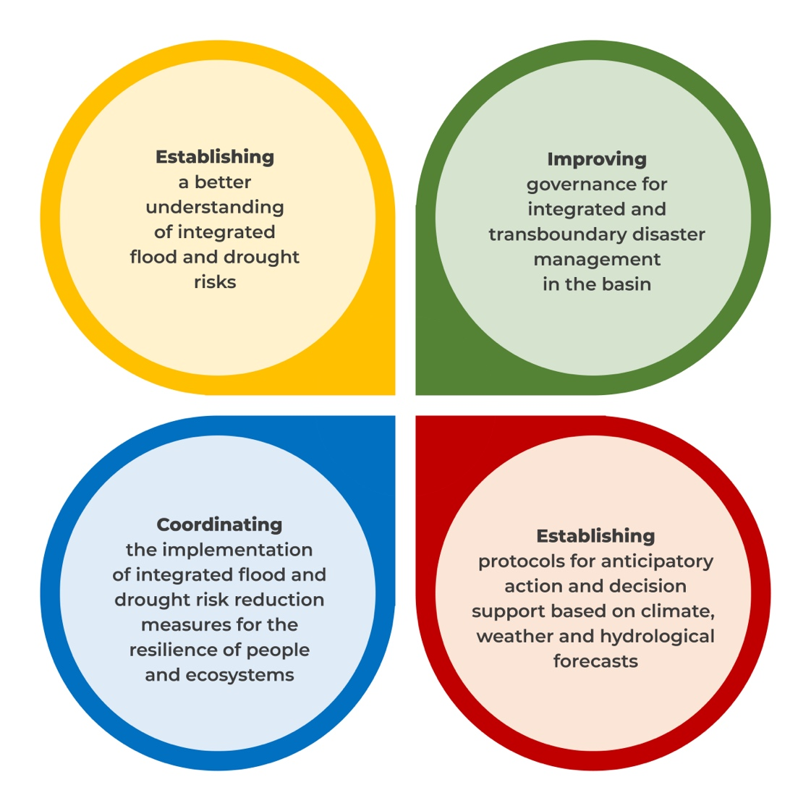

*Figure 2. Main elements for integrated and transboundary risk management.*

To these ends, it promotes:

* the harmonization of national policies, legislation, regulations and strategies for flood and drought risk management;
* the determination of the role and responsibilities of the stakeholders in flood and drought risk reduction and management;
* dialogue and consultation between the States Parties in the planning, design, implementation and management of flood and drought risk reduction measures, projects and programs;
* the strengthening of the institutional, technical and financial capacities of institutions involved in flood and drought risk reduction and management, as well as of local authorities and communities;
* scientific research, education and awareness raising on integrated flood and drought risk management issues;
* the strengthening of the links and transfers of information, technology and knowledge between hydrometeorological services and regional and national stakeholders in flood and drought risks prevention and warning.

This shared, transboundary and multi-sectoral framework governs all the measures and activities, public or private, underway or planned in the basin, having an impact on both flood and drought risk and their management.

Convinced that an integrated and transboundary strategy for the management of flood and drought risks constitutes an appropriate instrument to ensure the reduction of the related negative impacts in the Volta Basin, the States Parties subscribe to the adoption of this strategy hereafter named “The regional strategy for flood and drought risk reduction and management in the Volta Basin”.

# CHAPTER 2 – Situational Analysis

Chapter 2 is dedicated to the analysis of the flood and drought risk situation in the Volta Basin and the identification of the main challenges to be addressed through this strategy. The flood and drought risk profile is presented through a diagnosis of the current climate, occurrences and impact of floods and droughts in the basin, followed by future projections. The analysis is completed by a presentation of the institutional and policy framework in place for flood and drought risk reduction and management at basin level. Finally, the result of the analysis of stakes, challenges, gaps and opportunities for the integrated flood and drought risk management in the Volta Basin is presented.

## 2.1. Climate, occurrence and impacts of floods and droughts

* Climatic characteristics

The climate of the Volta Basin is the complex product of interactions between large-scale climatic influences (related in particular to the movement of the Intertropical Convergence Zone) and regional influences (for example the characteristics of the terrain or coastal climate). These interactions result in a natural climatic variability in the basin, both spatially along a North-South gradient, and temporally with cyclical seasonal behaviours, from one year to another and from one decade to another. Indeed, the northern part of the basin (the Sahelian part comprising Mali and northern Burkina Faso) has a hot and semi-arid climate (Kottek et al., 2016), with a marked five-months rainy season, while the rest of the basin is characterized by a humid tropical savannah climate, and pseudo-bimodal year-round rainfall in the south. Similarly, there is a precipitation gradient that increases from north to south of the basin, ranging from 500 mm/year to 1100 mm/year respectively, with 70% of annual precipitation occurring in July, August and September (UNEP-GEF Volta Project, 2013). However, less than 10% of rainfall contributes to river flow (Lemoalle, J. and De Condappa, D., 2009). Indeed, the average annual temperature is high in the basin, also ranging from 27°C in the south to 36°C in the north, implying high evapotranspiration rates (Gordon, C. et al, 2013; Jacob A., et al, 2022).

* Occurrence and impacts of floods

Floods are recurrent in the Volta basin and occur every year, and across borders. They have considerable impacts on the population of the six countries.

Different types of floods affect the basin, and are listed below (ECOWAS, 2020).

- Seasonal riverine floods, caused by rainfall on upstream watersheds, creates overflow of main rivers and flooding in low-lying areas. Floodplains and wetlands along major rivers such as the White Volta, Black Volta and Oti River are particularly vulnerable, especially between September and November when rivers reach their peak.

- Rising water tables can create localized conditions of soil saturation conditions in the lower Volta plains, downstream of the basin, following prolonged periods of rainfall. This type of flooding can have a significant impact on agriculture and can affect the stability of buildings and infrastructure in the basin.

- Urban floods are caused by sudden heavy rains that exceed the capacity of drainage systems, and by surface runoff. They are aggravated by the rapid increase in urbanization, the presence of impervious surfaces and the lack of maintenance of urban drainage systems in the basin. The cities most vulnerable to urban flooding in the basin are Ouagadougou and Bobo-Dioulasso in Burkina Faso, Tamale and Bolgatanga in Ghana, and Dapaong and Kara in Togo;

- Flash floods are caused by excessive rainfall and characterized by a rapid rise in the water level, locally, within minutes to hours, particularly in the steeper areas of the basin (notably in northern Ghana and Burkina Faso).

The risk of flooding in the basin appears to have worsened since the 1970s, associated with successive droughts, which have reduced the ability of soils to retain water, increasing runoff during heavy rainfall. These conditions were, for example, the cause of the disastrous floods of 2009 and 2010 (WMO, 2019). Indeed, for reference, the toll of the floods in 2010 in the Volta basin amounted to nearly 63 deaths, 62,000 houses damaged, 455 schools and 92 health centres destroyed[[2]](#footnote-3). In addition, a single event can locally affect several tens of thousands of people, such as, for example, the torrential rains of October 2019 associated with the release of water from the Bagré dam in Burkina Faso, which affected 27,000 people in the north-eastern region of Ghana[[3]](#footnote-4).

* Occurrence and impacts of droughts

In the Volta Basin region, as in West Africa, the high variability of precipitation in time and space is responsible for drought episodes, which have been increasing in number since the 1970s.

Different types of droughts can affect the basin, and are listed below (WMO, 2006):

- Meteorological drought is generally defined by a threshold corresponding to a certain deficit of precipitation over a specific period of time. The threshold chosen and the duration of the period vary from place to place. Indeed, meteorological drought is a natural phenomenon due to multiple causes, which vary from one region to another. Moreover, these parameters also vary according to the needs of the users, or the applications concerned.

- Agricultural drought is defined by an insufficient quantity of water in the soil to ensure the growth of crops rather than by the deviation of precipitation from normal over a given period of time. The infiltration rate varies according to several parameters: previous humidity conditions, slope, soil type, its water retention capacity and precipitation intensity.

- Hydrological drought is generally defined as the deviation of surface water and groundwater supply from certain average conditions at different times. Some complexity is associated with the fact that the various elements of the hydrological system (lakes, reservoirs, aquifers) are used for multiple and competing purposes. There is also a significant time lag between the disruption of precipitation and the moment when its insufficiency finds expression in the surface and underground elements of the hydrological system. The return of these elements to normal is slow, due to the long duration of the surface and underground water supplies recharge periods.

In the basin, drought episodes are particularly recurrent in the more arid northern part of the basin, in Ghana and Burkina Faso (GEF/UNEP/DHI/IWA, 2017). Today, some communities in the basin such as in the north-eastern region of Ghana, suffer from drought every year (Yiran & Stringer, 2016). Although few studies identify and examine the historical impact of these episodes at the basin level, in Burkina Faso alone, nearly 20 million people have suffered from periods of drought since the 1980s. Hydrological drought also affects the Volta Basin, involving streamflow deficits, lowered groundwater levels below recommended thresholds for extended periods of time with significant consequences for water access, irrigation, and ecosystem preservation (Water Charter- ABV, 2018).

## 2.2. Flood and Drought Risk Profile in the Volta Basin

Within the framework of the VFDM project, a probabilistic flood and drought risk analysis was conducted for the Volta Basin, considering current and projected climate conditions. The results of this analysis and the recommendations for policies, which consider flood and drought risks, constitute the core of the Volta Basin Risk Profile (CIMA, WMO, VBA, GWP-WA, 2022).

### 2.2.1. Estimation of the multisector impacts of floods and droughts

According to the recent Risk Profile Analysis study of the Volta Basin, focusing on riverine flooding (CIMA, WMO, VBA, GWP-WA, 2022), the average number of people affected per year in the basin approaches thirty thousand (Figure 3). Of the six States Parties, the situation is most worrying in northern Ghana and northern Burkina Faso. Floods also affect the road network and hundreds of thousands of hectares of agricultural and protected land on average per year. In addition, annual flood-related in the built-up area average about 25 million USD per year.

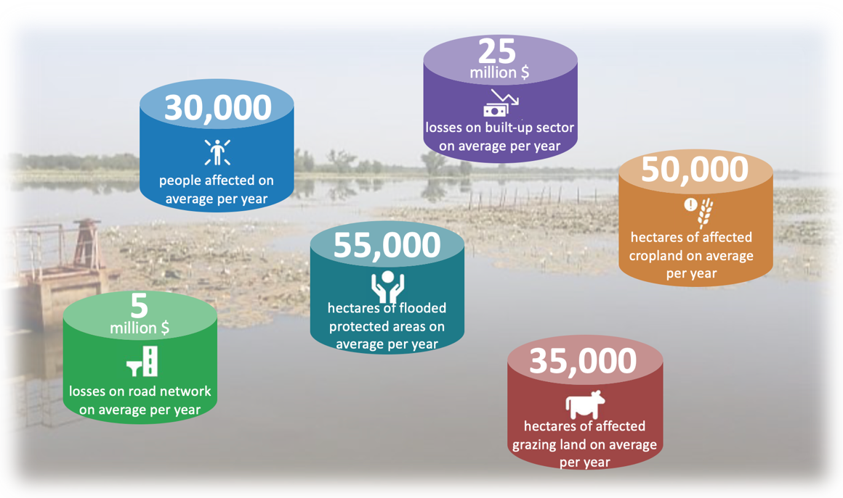

*Figure 3. Average annual losses (AAL) due to river flooding for different indicators, estimated according to current climatic conditions in the Volta Basin (elaboration from CIMA, WMO, VBA, GWP-WA, 2022)*

The basin risk profile reveals that more than 4.5 million people are exposed to severe drought conditions per year (Figure 4), particularly in the North (CIMA, WMO, VBA, GWP-WA, 2022). The agricultural sector, depending mainly on rain-fed agriculture, is the first to be impacted. The drought significantly affects annual production in the six countries of the Volta Basin (particularly in Mali and Burkina Faso), and has a worrying impact on food security. In addition, these losses have strong economic repercussions; for example, drought-related losses in maize production represent an average annual loss of nearly US$17 million. Droughts also have a significant impact on livestock and livelihoods of pastoralist communities in the Volta Basin, as well as on protected areas: on average, 5 million animals and 750,000 hectares of protected areas per year are exposed to severe drought conditions (CIMA, WMO, VBA, GWP-WA, 2022).

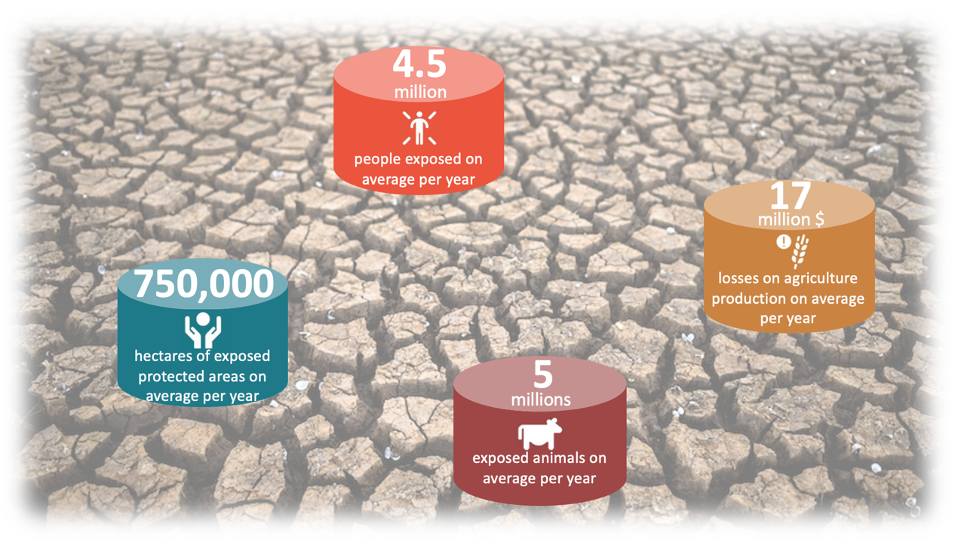

*Figure 4. Mean annual losses (AAL) due to droughts for different indicators according to the risk profile of the Volta Basin current climatic conditions (elaboration from CIMA, WMO, VBA, GWP-WA, 2022)*

### 2.2.2. Projections: impacts of climate and demographic change on flood and drought risks

* Future changes

Climate change is one of the major factors influencing disaster risk in the Volta Basin. In West Africa, global warming has already led to changes in temperature, rainfall, and the frequency and intensity of storms (UNEP-GEF Volta Project, 2013). The intensification of this phenomenon is expected in the coming decades. Indeed, on a global scale, the IPCC's SSP3-RCP7.0 scenario, predicts a doubling of CO2 emissions, and a global temperature increase between 2.8°C and 4.6°C by 2100.

The recent Volta Basin risk profile analysis study (CIMA, WMO, VBA, GWP-WA, 2022) was conducted using different global circulation models projected to the medium (2050) and long term (2080). It reveals a general warming trend in the Volta Basin region of up to 3.1 °C around 2080. Regarding the impact on rainfall patterns, there is no consensus in the studies due to the high intrinsic and multi-scale variability of the climate in West Africa. However, climate change is likely to result in more intense and temporally concentrated rainfall and runoff events, as well as a delay in the rainy season (Van De Giesen et al., 2010). In addition, the decadal (decade-to-decade) cyclic climate behaviour alternating consecutive wet and dry periods is also expected to continue in the future according to global circulation models (Liersch et al., 2019). Predicted climate variability will lead to an increase in the magnitude and frequency of extreme events and an increase in drought impacts even in a hydrological regime of average river flow increases. Years with little precipitation will be more frequent, alternated by years with more precipitation (CIMA, WMO, VBA, GWP-WA, 2022).

In addition to climate change, population growth projections place additional pressure on the Volta Basin and its resources. Indeed, according to United Nations projections, the basin's population is expected to grow at a rate of between 2.5% and 3%, reaching nearly 59 million people in 2050, with a greater increase in its upstream portion (Williams, 2016).

* Possible impacts of climate change on the risk of floods and droughts

The Volta Basin risk profile analysis (CIMA, WMO, VBA, GWP-WA, 2022) addresses the possible evolution of the impact of climate and demographic change on flood and drought risk. The results show that future projections only exacerbate current trends in the risk profile, especially spatially. Addressing today's situation and priorities is then an emergency for the future.

By 2100, nearly three times as many people as today will be affected by flooding in the Volta Basin, possibly nearly 80,000 people per year. A flood with a 50-year return period (loss) could then affect up to 165,000 people. Average annual losses to the built environment could exceed US$4 million in Ghana, and agricultural losses could increase by up to 40%. On the other hand, an increase in water availability and hydropower potential is expected for the period 2017-2100, particularly in the northern part of the basin, due to an increase in the intensity and frequency of rainfall and flooding, which is therefore not in contrast to a sharp increase in the impact of droughts in the region.

Indeed, by 2100, three times as many people will be affected by droughts in the basin, i.e., more than 15 million, distributed mainly in the North of the basin and in highly urbanized areas. Agricultural production losses are expected to increase (+36%) to nearly 23 million USD, with an increasingly marked contrast between the north and the south, and losses per hectare more significant in Burkina Faso (30-35 USD/ha per year). The same is true for livestock exposure, which is greater in the northern zone.

## 2.3 Flood and drought risk reduction in the Volta Basin: institutions and practices in place

### 2.3.1. Regional organs and mechanisms for disaster risk reduction and management

The governments of the six riparian countries of the Volta Basin created the Volta Basin Authority (VBA) by signing the “Convention on the Status of the Volta River and establishment of the Volta Basin Authority” on January 19, 2007. The mandate of the VBA is to promote permanent dialogue and sustainable development for an equitable sharing of benefits with a view to poverty reduction and better socio-economic integration. It is responsible, among other things, for harmonizing national water resources management policies in the basin through the adoption and implementation of the Integrated Water Resources Management (IWRM) approach throughout the basin. While the Convention provides a general framework for cooperation, it implicitly refers to the need to put in place the necessary protocols for effective implementation and optimal management of the basin.

The VBA has five main organs and mechanisms, described in the flowchart below (Figure 5).

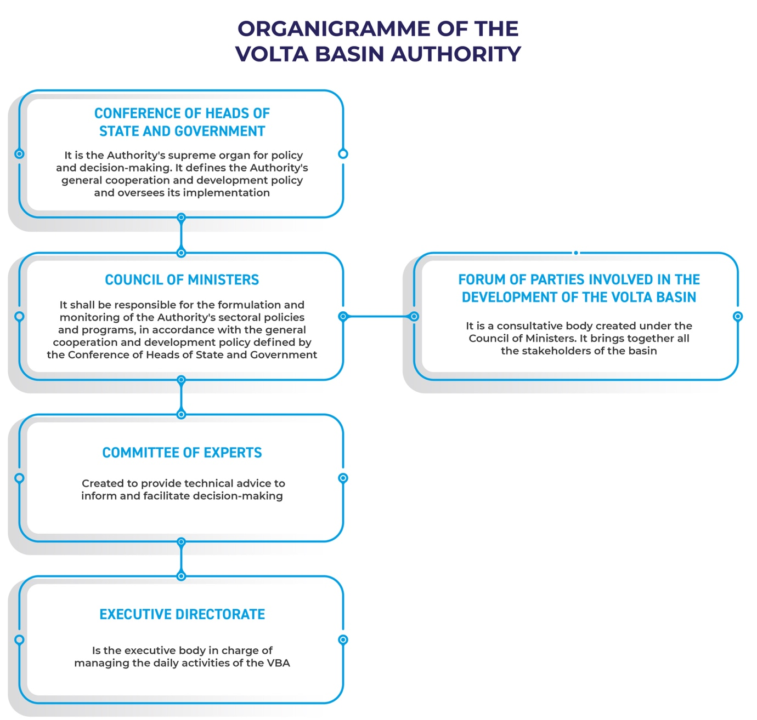

*Figure 5 : Organization chart of the authorities of the Volta Basin Authority (Schmeier, 2010).*

A National Focal Structure (NFS) has been established in each member state to oversee the implementation of national programs and to provide a link between the Executive Directorate and the former at the local and operational levels.

Regarding disaster risk management, the Authority facilitates, for example, bilateral transboundary cooperation for the evacuation of excess water from dams between Burkina Faso and Ghana. More specifically, the VBA Water Charter outlines the commitment of the six States to put in place specific measures for the prevention and management of the impacts of floods and severe low flows (Articles 61 and 62), as well as for adaptation to climate change (Chapter 7) in relation to water resources management.

In addition to the VBA and its organs, there are several institutions and organizations working on drought and flood risk reduction in the Volta Basin region. In particular, the Economic Community of West African States (ECOWAS) is home to several institutions working in the area of hydrometeorological services, including: the AGRHYMET Regional Centre, the West African Science Service Centre on Climate Change and Adapted Land Use (WASCAL), the Permanent Inter-State Committee for Drought Control in the Sahel (CILSS), and the Regional Specialized Meteorological Centre (RSMC) of the WMO.

ECOWAS has also developed strategic documents in the area of disaster management, which provide guidance to Member States and their national institutions:

* the Disaster Risk Reduction Policy, and the Action Plan 2015–2030 based on the Sendai Framework, which contain a line of action to support the integration of disaster risk reduction into climate change adaptation, in particular drought management and combating desertification;
* the Early Warning Strategy and the Regional Flood Risk Management Strategy (and its 2020-2025 action plan);
* ECOWAS Gender Strategy and Action Plan for Disaster Risk Reduction (ECOWAS DRR GSAP, 2020-2030).

A number of regional strategies, projects, and programs have an impact on the development of disaster risk reduction practices in the Volta Basin, including:

* the Great Green Wall (GGW) Initiative in the Sahara and Sahel launched in 2007 by the African Union, which has helped to address land degradation and desertification; this includes two Volta Basin countries (Mali and Burkina Faso);
* the Global Water Partnership's (GWP) regional Integrated Drought Management Programme in West Africa (IDMP WAF), which has the overall objective of building a strong partnership to build resilience to drought and climate change in the region, using an IWRM approach;
* the Africa Hydromet Program, launched in 2016 and implemented by the World Bank Group, through the Global Facility for Disaster Risk Reduction and Recovery (GFDRR), which has improved hydrometeorological services, early warning and response systems in Africa; it focuses on solutions for rain-fed agriculture and aims to improve the timeliness and accuracy of weather, climate, and hydrological forecasts;
* the Sub-Regional Action Programme, which aims to develop and strengthen resilience and adaptation capacities to climate change and extreme weather events in West Africa; the program was developed by the Economic Community of West African States (ECOWAS), the Permanent Inter-State Committee for Drought Control in the Sahel (CILSS), the Economic Commission for Africa (ECA), and the African Centre of Meteorological Applications for Development (ACMAD);
* the African Union Climate Change Strategy for the period 2020-2030 which provides a framework to guide the actions of African States and regional organizations towards low-carbon development, with a focus on green and resilient growth, strengthening the adaptive capacities of African economies, societies and ecosystems;
* the ECOWAS Regional Climate Strategy (RCS) and Action Plan (2022-2030), which contributes to the implementation of the African Union Climate Change Strategy for the period 2020-2030 in the West African region.

In the sub-region, the ongoing VFDM project aims, among other things, to contribute to the analysis of existing strategies, policies and plans for disaster risk reduction and management in the six riparian countries of the basin and to harmonize them with a long-term transboundary action plan for building resilience at the national and transboundary levels, especially to floods and droughts.

### 2.3.2. National organs and mechanisms for disaster risk reduction and management

With the assistance of ECOWAS and regional partners, the six Volta Basin states have established national disaster risk reduction mechanisms, within the framework of the program ACP-EU NDRR, aiming at strengthening the capacities of African Regional Economic Communities and Member States in coordination, planning and policy advisory for disaster risk reduction. The degree of development of these flood and drought management mechanisms at the national level varies from country to country:

* At the legal level, there are a number of legal instruments (laws, codes, decrees) at the national level that frame the management of floods and droughts through texts referring to the

environment, natural resources, water, climate change, land and biodiversity.

In terms of disaster management, only Burkina Faso has a Framework Law “on the Prevention and Management of Risks, Humanitarian Crises and Disasters” (Law 012/2014) which takes into account the elements of prevention, preparedness and management of disaster risks (Ouedraogo, 2022). Similarly, Ghana, through Act 927 formed the National Disaster Management Organization (NADMO) to implement disaster prevention, disaster risk reduction, climate risk management policy, as well as international, national, regional and district management plans (NADMO Act 927, 2016).

* All six countries have developed a national disaster risk reduction strategy. Based mainly on disaster risk response, the national strategies are now trying to integrate action plans to improve disaster prevention, as in Benin, Burkina Faso, Côte d'Ivoire and Togo, through the Drought Management Plan (2019).
* A multi-stakeholder institutional framework in the form of a Platform is in place in each country. Composed of state stakeholders, local authorities, NGOs and associations, these platforms benefit from the support of technical and financial partners for capacity building and intervention measures in disaster risk management.

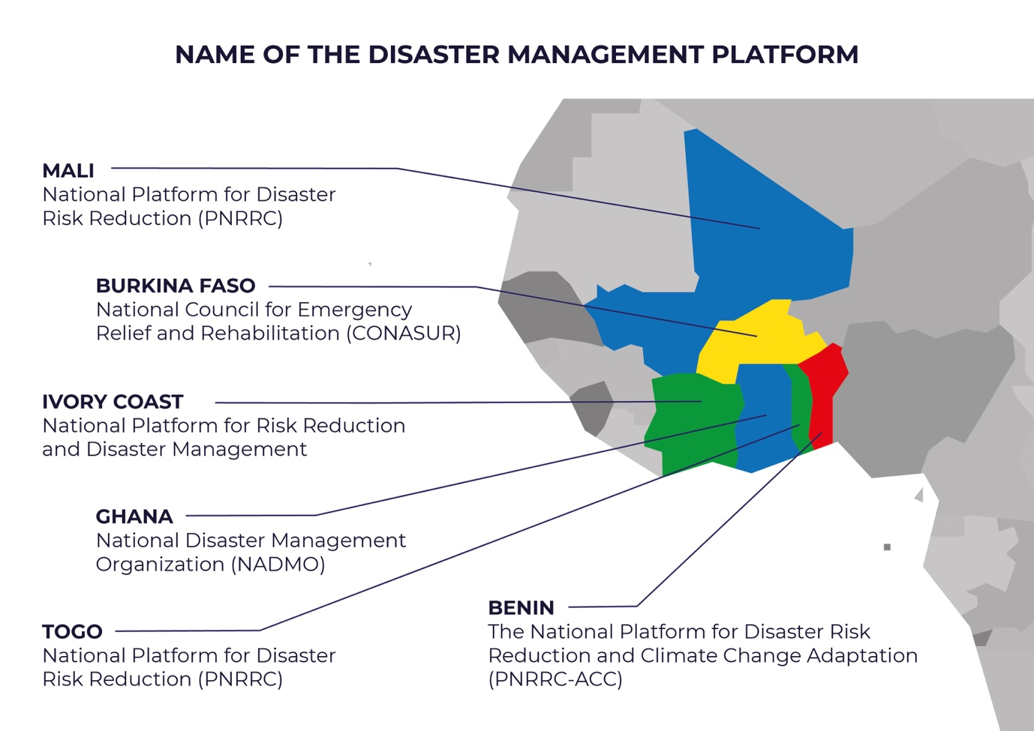

*Figure 6: Platforms for Disaster Risk Reduction and Management in Volta Basin Countries.*

In addition, disaster risk management is addressed at the national level in (i) National Action Programmes of Adaptation to Climate Variability and Change, with emphasis on disaster preparedness and response; (ii) National Climate Change Adaptation Plans; (iii) Master Plans for Water Development and Management (SDAGE); (iv) Sectoral policies concerning agro-silvo-pastoral production and environment-water-sanitation issues; (v) Water Codes or Regulations and national water policies, which include at the national level the implementation of measures aimed at mitigating the effects and preventing the damage caused by extreme hydrological phenomena (floods and droughts).

### 2.3.3. Early warning systems developed with support of regional and international stakeholders

The development of early warning systems by national institutions including meteorological and hydrological services is a key element for the prevention and management of drought and flood risks in the Volta Basin. With the help of regional and international institutions, including the ECOWAS Meteorological Program adopted in 2017, and in collaboration with WMO and the AGRHYMET Regional Centre, the six countries have been able to strengthen the capacity of their hydrometeorological services, and establish early warning systems through technical and financial support.

To this end, in July 2020, the ECOWAS Commission and the Permanent Inter-State Committee for Drought Control in the Sahel (CILSS) endorsed the AGRHYMET Regional Centre as the Regional Climate Centre for West Africa and the Sahel (CCR-AOS). This centre now provides for 5 of the 6 countries of the Volta Basin (Ghana not included):

(i) operational weather and climate forecasting activities;

(ii) operational climate monitoring activities;

(iii) operational database services in support of long-range forecasting and climate monitoring;

(iv) operational capacity building;

(v) management and dissemination of meteorological and climatological information.

The establishment of a regional multi-hazard early warning system is one of the objectives of the ECOWAS 2015-2030 Action Plan. A memorandum of understanding has been established between ECOWAS and the African Risk Capacity (ARC), allowing the exchange of knowledge, data and methods for the early detection of hazards, with the aim of strengthening their capacity to prepare for and respond to disaster risks.

In the sub-region, one aspect of the ongoing VFDM project aims to address the need to harmonize basin EWS, to base forecasts on impacts and to strengthen the dissemination of warnings, with the implementation and operationalization of a basin-wide transboundary early warning system, the myDewetra-VOLTALARM platform, for floods and droughts in the Volta Basin.

### 2.3.4. Early warning systems in place at national and local levels

According to the results of the analysis of national capacities and needs for the development of forecasting and early warning systems in the framework of the VFDM project (National Consultation Reports 2020 available online at <https://www.floodmanagement.info/volta-basin/deliverables>), there are not yet fully operational early warning systems at the national level, for flood and drought risks. Several EWS initiatives are under development in each country, at different levels, generating information and alerts through different web portals, but work is needed to harmonize these projects. The systems in place are very rarely impact-based, and remain insufficient in terms of communication and dissemination of messages to be useful to the population. In addition, alerts are often not linked to national action or decision-making protocols. Finally, these initiatives suffer from a lack of long-term follow-up, human capacity to maintain them, and coordination at the national and regional levels.

Among the list of initiatives to establish early warning systems in the Volta Basin region, the most relevant are referenced below.

* The Flood Early Warning System (FEWS-Volta), which was developed by the World Bank and the Water Resources Commission, Ghana in 2012 for the White Volta Basin, later extended to the Oti basin in Ghana and Togo (VBA, WMO-GWP, 2016) by HKV. The EWS uses a coupled hydrological and hydraulic model and provides a daily forecast with a 5-day lead time based on satellite rainfall data. The system is currently not operational due to technical reasons at the hosting agencies.
* Burkina Faso has equipped itself with early warning systems that are more oriented towards the risk of drought than floods, as, for example, with the establishment of the Regional Monitoring System for Food Security, thanks to the ECO-AGRIS project (2015-2018). The project has strengthened information systems at different local, national and regional scales to meet information needs for food and nutrition monitoring, vulnerability analysis, decision support, with the objective of predicting food or nutrition crises and targeting necessary interventions.
* In Côte d'Ivoire, SODEXAM is working to set up a system of vigilance, warning, and climate and weather services for users (VIGICLIMM, 2020). The VIGICLIMM project, financed by the French Development Agency (AFD), aims to improve the quality of climatic information by ensuring flood prevention, agricultural adaptation to climate change, food security, etc. It ensures the strengthening, modernization and upgrading to international standards (ICAO, WMO) of all meteorological observation infrastructures and the climate information system of SODEXAM, as well as its human capacities.
* In Benin, the EWS-Benin project (implemented by the UNDP between 2013 and 2017) enabled the strengthening of climate information and early warning systems for hydroclimatic risks in Benin[[4]](#footnote-5). Five (5) platforms for the visualization and analysis of hydrological data have been installed with the various public institutions to strengthen early warning for floods; in addition, the Standard Operating Procedure for Warning Communication (MON in its French acronym) , through local focal points in charge of disseminating warnings for vulnerable populations, has been formalized and implemented.
* In Togo, the Red Cross movement is working on forecast-based financing projects, setting up early warning systems for floods and droughts in several regions.
* The World Bank-WMO CREWS project (2017-2021) focuses on modernizing the hydrometeorological flood warning service in Mali. A Flood Prediction Tool for the Inner Niger Delta (OPIDIN) is used to make predictions about peak floods. It works based on daily water level readings taken by the National Directorate of Hydraulics (DNH) and its regional offices.
* As part of the Flood and Drought Management Tool project, the UNEP-DHI partnership designed and implemented a web portal (https://www.flooddroughtmonitor.com/) to access near-real-time flood and drought data and assess drought occurrence based on a series of drought indices, specifically for three pilot watersheds, including the Volta River Basin (CTCN, 2017).

## 2.4 Issues, Challenges, Gaps and Opportunities for Integrated Flood and Drought Risk Reduction and Management in the Volta Basin

This section shows the result of the analysis of the issues, challenges, gaps and opportunities for the integrated flood and drought risk management in the Volta Basin, resulting from an in-depth documentation work, consolidated by the expertise resulting from the national workshops.

Droughts and floods have devastating consequences in the sub-region on many levels, whether in terms of loss of life or displacement of populations, economic losses, environmental or cultural degradation. Consequently, the issues associated with the integrated flood and drought risk management in the basin are considerable:

* Social issues include reducing the loss of lives (particularly of the most vulnerable people), and the risks associated with the displacement of populations, such as the loss of security, stability and the continuity of family and community ties. In addition, reducing the risk of floods and droughts can minimize impacts on people's health by limiting water-borne and undernutrition-related diseases. It can also strengthen social cohesion and help prevent conflicts between communities in the basin.
* The major economic issues include protecting infrastructure and reducing repair costs, as well as reducing agricultural losses through early warning systems and risk-based insurance mechanisms. Integrated management of these risks can contribute to regional economic development by reducing reconstruction costs and encouraging and protecting private, foreign and domestic investment and tourism in the sub-region.
* Environmental issues are related to the conservation of the sub-region's biodiversity and ecosystems, as well as the preservation of wetlands. A better flood and drought risk management can also contribute to solving cross-border problems related to the quality of surface and ground water, the degradation of soils and vegetation in the face of erosion, and increased sedimentation in watercourses.
* Cultural issues, such as the protection of historical sites and the preservation of local traditions (also affected by flood and drought events in the basin) are also central to disaster risk reduction and management initiatives. In addition, risk reduction and management strategies can incorporate existing traditional knowledge and practices for coping with floods and droughts and promote education and awareness of the risks associated with these events and measures to protect against them.

In order to address these issues related to the reduction and integrated management of flood and drought risks in the Volta Basin, four major challenges have been identified. For each challenge, the result of the needs, gaps and opportunities analysis, carried out upstream and consolidated during national workshops, is presented.

Challenge 1: A better understanding of flood and drought risks, shared at the basin level.

Improving the understanding and access to data and information on flood and drought risks is a prerequisite for the implementation of a flood and drought risk reduction action plan for the Volta basin. It must be done through the mobilisation of resources and knowledge between the States Parties and the institutions of the basin, a reinforced and harmonized analysis of the flood and drought risks affecting the basin, as well as the sensitization of the populations to these risks.

*Table 1. Description of needs, gaps and opportunities connected to Challenge 1 for flood and drought risk reduction and management in the Volta Basin.*

|  |  |  |
| --- | --- | --- |
| **Needs** | **Gaps** | **Opportunities** |
| Mobilising resources and knowledge through:  - common databases (e.g. for hydro-meteorological, socio-economic data, and disaster impacts)  - a harmonized data and knowledge sharing framework.  - strengthening, upgrading and automation of hydro-meteorological monitoring networks in the basin. | -Lack of exchange of data and knowledge on drought and flood risks between Member States  -The network of hydrological, hydrogeological and meteorological stations are neither optimized nor maintained.  - inadequate human resources. | Willingness and commitment in terms of sharing and harmonizing hydro-meteorological data. For example, through the study to establish a regional system for the exchange of data and information relating to the Volta Basin (UNEP/GEF Project) and Article 23.2 of the Water Charter (Article 23.2) |
| Analyse disaster risks in a common and thorough way (e.g. studies of different types of floods and droughts, groundwater resources of the basin, and social vulnerability of the communities) | There are few baseline studies, harmonized at the basin level, on the different threats related to floods and droughts, groundwater behaviour, and the exposure and vulnerability of populations and assets. | Existence of the Volta Basin Risk Profile (CIMA, WMO, VBA, GWP-WA, 2022): a first analysis of basin-wide risks and potential annual impacts related to floods and droughts, under current and projected climate conditions. It could be extended, depending on data availability, to other climate scenarios and sectors of interest. |
| Inform and sensitize the populations of the basin about flood and drought risks | There is no systematic program to raise awareness of flood and drought risks among communities in the basin. | Partnerships with local organizations are in place (NGOs, religious organizations, and community groups) and the presence of local media can support efforts to raise awareness and sensitize the population and communities. |

Challenge 2: Strong governance and institutions for better integrated drought and flood risk management in the basin

The strengthening of basin governance and institutions is necessary for better integrated management and reduction of drought and flood risks at the basin level. Indeed, the Volta Basin suffers from the lack of coordination, collaboration and harmonization between the relevant bodies involved in the reduction and management of flood and drought risks, at the regional level, and among members states. The gap and opportunity analysis points to the urgency of integrating and budgeting for risk prevention measures into national policies, as well as establishing a strong framework for consultation and decision-making at the basin level. There is a common political will to address climate change, recurrent floods and droughts in an inclusive manner. However, there are limited financial and human resources to invest in policies, programs or projects that integrate disaster reduction and management, climate and development. Indeed, the issue of transferring international funds for climate disaster prevention and recovery to Southern states was at the heart of discussions at the 2022 Sharm el-Sheikh Climate Change Conference (COP27).

*Table 2. Description of needs, gaps and opportunities connected to Challenge 2 for flood and drought risk reduction and management in the Volta Basin.*

|  |  |  |
| --- | --- | --- |
| **Needs** | **Gaps** | **Opportunities** |
| Strengthen cooperation, coordination and harmonization between institutions and States Parties at regional, national and local levels. | - Lack of cooperation, coordination and harmonization mechanisms between institutions in charge of disaster risk reduction and management between countries  - National disaster risk reduction and management policies of the six riparian countries are not harmonized among themselves | -An appropriate multi-stakeholder institutional framework exists at the national level for the reduction and management of floods and droughts.  - Governance is in place at the basin level with the Volta Basin Authority, aspiring to coordinate and harmonize disaster risk management in the basin in an integrated and transboundary manner |
| Effective integration of drought and flood risk reduction into national policies and strategies and budgeting of interventions | - Focus of strategies on emergency response and reaction rather than prevention and preparedness interventions  - Lack of a transboundary strategic plan linking water and natural resource management to basin-wide disaster reduction and management.  - Weak mobilization of funding for DRR | - Specific disaster risk reduction policies, strategies and plans exist at national and regional levels  - Major awareness of the importance of disaster risk reduction among institutional stakeholders as a means of optimizing the use of financial resources |
| Establish a framework for consultation and decision-making among stakeholders in the Volta Basin | - Inefficient/operational institutional and legislative mechanisms Institutional and legislative mechanisms not very effective/operational  - Lack of clarity in the roles of the consultation bodies  - No operational basin-wide contingency plan for flood and drought risk management. | - There are many consultative bodies involved in disaster management in the basin and regional stakeholders that can facilitate the establishment of effective consultative mechanisms  - Willingness and commitment of stakeholders in terms of information sharing for better consultation and harmonization of decision-making processes in flood and drought risk management. |

Challenge 3: Integration of flood and drought risk reduction measures at the basin scale for population and community resilience

A number of drought and flood risk reduction measures are in place as a result of various projects implemented in the basin. For example, in Burkina Faso, a drainage system exists to manage potential flooding in the city of Ouagadougou, but its operation is compromised by garbage that accumulates in the channels blocking the system. With respect to drought issues, in Ghana, large gorges have been constructed to retain water for hydroelectric generation and ensure water availability during dry seasons. However, to address flood and drought threats in the Volta Basin, and reduce potential impacts on communities, risk reduction measures must be identified in an inclusive manner and coordinated at the basin level by establishing protocols to ensure communication and minimize transboundary effects. The gap and opportunity analysis also suggests strengthening land management policies and promoting more climate resilient agriculture.

*Table 3. Description of needs, gaps and opportunities connected to Challenge 3 for flood and drought risk reduction and management in the Volta Basin.*

|  |  |  |
| --- | --- | --- |
| **Needs** | **Gaps** | **Opportunities** |
| Establishment and coordination of a network of drought and flood risk reduction measures, integrating the issue of transboundary effects | Risk reduction measures are not designed in an integrated and transboundary way, but rather with a local or national approach | DRR measures are already in place in the basin and they could be considered as pilot examples to be evaluated for an extension on a regional scale according to an analysis of similarity of conditions in the basin. |
| Integrate local knowledge and the perspective of women, youth and people living with disabilities into all disaster reduction measures | DRR measures do not systematically include local knowledge and the perspective of women, youth and people living with disabilities. | There is a common political will to address disaster risk in an inclusive manner. Gender issues, as well as the needs of the most vulnerable groups, are increasingly considered in policies, laws, strategies and plans. |
| Strengthen land management policies for community and agro-silvo-pastoralist sector resilience to floods and droughts | Land-use and building guidelines are often limited to flood risks, with little emphasis on resilient development, and are generally not (or only weakly) implemented.  Drought risk is often considered in specific plans and strategies and not in combination with floods. | - National guidelines for land use planning exist.  - There is a major awareness of the importance of an interaction approach between land use planning and risk reduction and management, and of the need to consider floods and droughts in an integrated way. |
| Promote agriculture that is more resilient to climate change, | Lack of funding for awareness programs on agricultural practices adapted to climate change | A roadmap for innovative and climate-smart agricultural practices has been developed for the Black Volta Basin in Ghana (UNDP GEF Small Grant Programme) |

Challenge 4: Accessible decision support tools based on early warning

Reducing flood and drought risks at the basin level requires the strengthening of early warning systems and the implementation of preventive action protocols based on the integration of hydrological, climatic and weather forecasts. The strengthening of the VOLTALARM system as an operational EWS at the basin level is an opportunity for flood and drought risk reduction. However, it requires a focus on effective communication and dissemination of warnings. In addition, the development of early action protocols for each sector and administrative level must be prioritized, detailing the procedures to be implemented in the event of the triggering of early warnings for floods and droughts. Finally, the analysis of the situation of the basin reveals the absence of decision support tools for the allocation of water resources and the management of agricultural activities and practices.

*Table 4. Description of needs, gaps and opportunities connected to Challenge 4 for flood and drought risk reduction and management in the Volta Basin.*

|  |  |  |
| --- | --- | --- |
| **Needs** | **Gaps** | **Opportunities** |
| Strengthening of the VOLTALARM System as EWS for floods and droughts and dissemination of impact-based early warnings at the transboundary level. | Weakness of national systems in terms of communication and rapid dissemination of climate information and warnings. | - National hydro-meteorological monitoring and forecasting structures in place, as well as mechanisms for interaction and communication with civil protection agencies (e.g. MON in Benin)  - Ongoing EWS initiatives at national/local level: MultiRisk EWS (SAP/MR), W-Arly-Pendjari complex (WAP), Food SAP (Burkina Faso), FEWS Oti and Volta Blanche system, the myDewetra-VOLTALARM platform  - Many initiatives to strengthen and unify EWS for floods |
| Development of Early Action Protocols for flood and drought risks, adapted to each sector. | There are no national mechanisms implementing floods and droughts anticipatory actions. | Possible collaboration with National Red Cross Societies working on the development of Early Action Protocols for floods, as for example in Togo. |
| Develop decision support tools for the management of water resources and agricultural activities, based on seasonal and sub-seasonal climate and hydrometeorological forecasts. | Lack of operational tools for water resources allocation and management or decision support tools for agricultural practices, based on seasonal forecasts. | The VBA has recently obtained funding from the African Development Bank Group for the establishment of a hydraulic model for the allocation and management of water resources in the basin. Efforts could be pooled with the implementation of the strategy. |

# CHAPTER 3 – Vision, objectives and strategic orientations

The development process of this strategy is based on: (i) the results of studies derived from the implementation of the VFDM project, including the flood and drought Risk Profile of the Volta Basin; (ii) guidelines, policies and strategies for risk reduction and management at regional, national and local levels and (iii) the contribution of stakeholders organized around the conduct of six national workshops and a regional workshop bringing together stakeholders of the basin for the co-construction, deepening and validation of the vision, objectives and orientations of the strategy, as well as the action plan.

The development of this strategy is based on an inclusive methodological approach that values ​​the knowledge and experience of basin stakeholders in order to stimulate active participation in the definition of strategic actions and ownership of the document. The proposals concerning the vision, the general objective and the strategic orientations of the strategy have been consolidated into a common vision presented in this chapter. The action plans associated with the strategy, presented in Annex 1 and organized by strategic orientation, are the result of the compilation of proposals from the various working groups created during the six workshops.

## 3.1 Vision

The vision of the regional strategy for flood and drought risk reduction and management in the Volta Basin, common to the six States Parties, is presented below:

*By 2030, the Volta Basin has operational mechanisms (institutional, legislative, and financial) for concerted and integrated flood and drought risk management, ensuring community resilience to climate change, sustainable and inclusive socio-economic development, as well as protection of ecosystems and optimization of water resources.*

## 3.2 Objectives of the strategy

The general objective of the strategy, harmonized from the proposals resulting from the six national workshops, is presented below:

*To mitigate the current and future impacts of floods and droughts on the communities and ecosystems of the Volta Basin, through preventive, integrated, inclusive and sustainable management of risks and water resources, and through the consolidation of institutional, technical, scientific and financial capacities of the VBA, and the strengthening of cooperation and collaboration between the States Parties.*

Based on the analysis of needs, gaps and opportunities, and the major challenges identified for the reduction and management of flood and drought risks in the Volta Basin, four strategic axes were selected from the consultations carried out during the national workshops, in order to meet the general objective of the strategy. The strategic orientations are as follows:

1. Improve common knowledge of flood and drought risks at the basin level.
2. Strengthen governance and institutions for better integrated flood and drought risks management in the basin.
3. Develop integrated flood and drought risk reduction measures at basin level in a transboundary manner for community resilience.
4. Develop early warning and decision support systems for disaster prevention and preparedness.

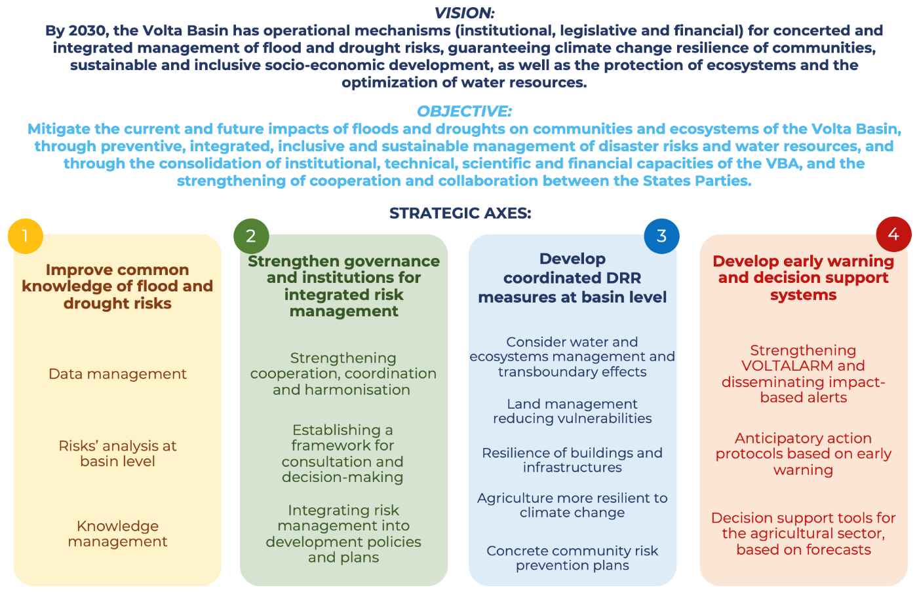

*Figure 7: Summary diagram of the disaster risk reduction and management strategy in the Volta Basin.*

## 3.3 Guidelines of the strategy

The main guidelines of the strategy, acting in a transversal manner, include:

- capacity building at all levels.

- active participation of all the technical, political and civil society stakeholders in order to guarantee the implementation of the integrated strategy at all levels.

- promotion of the information sharing, the exchange and transfer of knowledge and experiences at transboundary level

- inclusive approach, considering women, youth and the most vulnerable groups in all risk management measures.

- dialogue, commitment and partnership with the international community, continental and regional bodies.

- application of most of the measures of the action plans at the community level.

## 3.4 Orientations of the strategy

In order to address the challenges of integrated flood and drought risk reduction and management in the Volta Basin, the Volta Basin Authority, the Member States, the National Bodies propose to implement this strategy to achieve the objectives set, with the support of other regional, continental and international institutions. For each of the four strategic axes, the objective and means of action are described and an action plan is drawn up and presented in Annex 1.

**1: Improve common knowledge of flood and drought risks at basin level**

This strategic orientation aims to strengthen the monitoring and analysis of all the factors (hazard, exposure and vulnerability) increasing the risk of floods and droughts in the basin, to support an action plan promoting integrated and sustainable data and knowledge management. The following three components will be developed in the action plan.

* Data management that is a key element in achieving this objective. It begins with the strengthening of hydrological, hydrogeological, and meteorological monitoring networks and their maintenance. In addition, efforts are required for the continuous collection of data, analysis, processing and storage. Finally, the pooling of hydrometeorological data as well as all data associated with risks (impacts of disasters, socio-economic data, exposure data) is possible thanks to the establishment at the basin level of harmonized frameworks for data sharing and investment in common archiving platforms.
* Strengthening of the analysis of the risk of floods and droughts at basin level. Activities that could complement the risk profile analysis, such as an analysis of the socio-economic vulnerability of populations, potential impacts on critical infrastructures, groundwater levels, and different types of floods and droughts will provide in-depth and common knowledge of the risks affecting the basin.
* Sustainable knowledge management and understanding of flood and drought risks. This strategy supports the implementation of actions aimed at informing and sensitizing the populations of the basin on risks and facilitating the sharing and dissemination of information and knowledge related to risks.

**2: Strengthen governance and institutions for better integrated flood and drought risk management in the basin.**

The objective of this strategic orientation is to strengthen, coordinate and harmonize institutional and regulatory mechanisms for flood and drought risks management at basin level. The implementation must be done by integrating the gender issue. Implementation should be done through:

* the strengthening of cooperation, coordination and harmonization between institutions and States Parties. The action plan proposes to work on a common institutional and regulatory framework as well as the organization of meetings to revitalize the stakeholders’ forum;
* the establishment of a consultation and decision-making framework among the stakeholders of the Volta basin. The proposal to draw up communication plans and contingency plans at basin level, allows the clarification of roles of different institutions in preparing for and responding to floods and droughts;
* the promotion of activities allowing the effective and inclusive integration of disaster risk management and its budgeting in development policies and plans of the basin.

**3: Develop integrated flood and drought risk reduction measures at basin level, in a transboundary manner, for community resilience.**

This third strategic orientation promotes the implementation of a coordinated network of measures at the Volta Basin level aiming at: i) minimizing the impact of floods and droughts on the most vulnerable communities by taking into account transboundary effects; and (ii) strengthening the resilience of the Agro-Silvo-Pastoral sector to current and future climate conditions through:

* the implementation of a coordinated network of flood and drought risk reduction measures, in an integrated manner. The Action Plan prioritizes nature-based solutions, optimizing basin water management, preserving ecosystems and minimizing transboundary effects;
* the strengthening of land use planning and sustainable land management policies to help reducing the exposure and vulnerability of communities and the Agro-Silvo-Pastoral sector to floods and droughts;
* the strengthening of land use planning and sustainable land management policies to help reducing the exposure and vulnerability of communities and the Agro-Silvo-Pastoral sector to floods and droughts;
* the maintenance and improve the resilience of buildings, structures and infrastructures;
* the promotion of an agriculture more resilient to climate change thanks to the strengthening of the capacities of stakeholders in the agricultural sectors, the establishment of subsidies, micro-credit initiatives;
* the co-development of community plans for the prevention of flood and drought risks, based on raising awareness and promotion of local risk knowledge.

**4: Develop early warning and decision support systems for disaster prevention and preparedness**

The objective of this strategic orientation is to support the stakeholders of the six riparian countries in the implementation of harmonized early warning systems for flood and drought risks, including protocols in place for triggering anticipatory actions. This strategic axis is in line with the EW4ALL global initiative launched by the Secretary-General of the United Nations, committing to ensuring that every person on earth is protected by an early warning system by 2027. To this end, it is proposed to strengthen the VOLTALARM platform and local capacities at different levels by:

* the strengthening the VOLTALARM platform as operational Early Warning System at basin level for the prevention of flood and drought risks. It emphasizes the importance of dissemination of early warnings by proposing actions that improve the communication and dissemination of warnings and hydro-meteorological forecast information opting for impact-based messages, adapted to the experiences and knowledge of beneficiaries and most vulnerable communities;
* the implementation of protocols allowing the triggering of anticipatory actions is proposed for the different sectors of the Volta basin.
* the promotion of the development of decision-making tools for the agricultural sector, for the management of water resources, and the choice of agricultural activities and practices, based on the knowledge and the integration of climate and weather seasonal and sub-seasonal forecasts.

# CHAPTER 4 – Means of implementation

This chapter emphasizes the different means to be considered for the implementation of the strategy, starting from the description of the roles of the different stakeholders at national, regional and local levels and the institutions with which to build cooperation and partnership mechanisms. It provides also indications concerning resources’ mobilization, monitoring and evaluation, sharing and valorisation of lessons learned.

## 4.1 Roles of key stakeholders at different levels

**VBA and regional levels**

The VBA is committed to play a key role in facilitating, through its Executive Directorate, the adoption of the Strategy and its Action Plan at the level of the Council of Ministers, so that this body, together with the Summit of Heads of State, can provide the necessary political leadership and advisory support for the implementation of the Strategy and its Action Plan. The Executive Directorate of the VBA will be responsible for coordinating and overseeing the implementation, taking the lead in the capacity building process, the mobilization of financial resources and the definition of the monitoring and evaluation framework being the lead institution for validating the implementation of the Strategy. It is also responsibility of the VBA Executive Directorate to coordinate the definition and selection of indicators for monitoring and evaluation, in partnership with the States Parties

Other regional stakeholders will be important for the success of this Strategy :

* institutions such as ECOWAS and CILSS will be able to support the VBA in the political leadership and in mobilizing the necessary financial resources for the implementation;
* GWP-WA will be able to support in the facilitation of political dialogue between the States Parties and the different institutions involved at national, sub-regional and regional levels, as well as in capacity building, technical support and resource mobilisation;
* from the point of view of technical support, the AGRHYMET centre will be able to support the capacity building process of the institutions involved, but also to contribute to resource mobilization.

**State Party level**

States Parties shall ensure that they provide the necessary political leadership regarding the objectives and results to be achieved at the national level and that they enhance the synergy between the strategy and national development plans and policies integrating the component of disaster risk reduction.

Through the relevant sectoral Ministries, they commit to ensuring the adoption, appropriation and integration of the strategy into national planning, as well as to support the implementation at regional level through a strong coordination approach, advocacy and allocation of financial resources.

The national agencies and structures concerned will contribute to the mainstreaming of the strategy at national level and to its implementation based on the specific mandate of each institution through a process of harmonisation of its projects and intervention within the framework of the strategy. They will also be able to contribute to the successful implementation of the strategy by promoting continuous capacity building and research initiatives related to risk reduction. These institutions will also contribute to resources’ mobilisation, technical review of the strategy, and to the monitoring and evaluation process by providing information on their contribution to the implementation of the strategy.

The National Focal Structures of the VBA commit to gather the contributions of the different national institutions contributing to the implementation of the strategy and to compile periodically summary reports on the status of implementation of activities to reduce flood and drought risks as part of the monitoring and evaluation process established by the DE of the VBA.

It will also be important to engage civil society stakeholders to support operationally the implementation of the strategy in terms of implementation of actions as well as in terms of mobilization of resources and monitoring and evaluation.

**Local level**

The active participation of community-based organisations (CBOs), such as municipalities, local assemblies, town halls, but also local non-governmental organisations, is crucial to enable ownership of the strategy also at the local level. Moreover, these stakeholders will be fundamental to enable the implementation of the strategic actions to reach a certain level of effectiveness and sustainability at all levels and truly strengthen the resilience of communities.

## 4.2 Cooperation and partnerships

A very important element will be the development of the framework of partnerships and cooperation agreements between States Parties but especially with regional, continental and international institutions and organisations. Priority actions will be defined through a roadmap to strengthen the mobilisation of partnerships, including tools and approaches for developing partnerships and cooperation agreements.

At the technical level, it will be necessary to consider establishing partnerships to support the implementation of the Strategy in terms of capacity building initiatives and resource mobilisation with:

* the Permanent Inter-State Committee for Drought Control in the Sahel (CILSS), which contributes in particular to regional water resource management policy, drought reduction and management and food security;
* The African Centre for Meteorological Applications for Development (ACMAD) and the AGRHYMET Regional Centre of CILSS, which operate largely as Climate Centres (for Africa and for West Africa respectively) and provide services such as capacity building in climatology, agrometeorology, hydrology, crop protection, geomatics and remote sensing, and the development of decision support tools for different sectors (agriculture, health, water and energy);
* the Agency for Air Navigation Safety in Africa and Madagascar (ASECNA), which provides aviation-related meteorological services for five of the Member States
* the West African Science Service Centre on Climate Change and Adapted Land Use (WASCAL), which is a large-scale climate service centre focused on climate change research and capacity building in West Africa, and is also the link for a network of regional and German universities;
* the West African Coastal Observation Mission (MOLOA), which is the coordination centre of a cooperation mechanism and technical network for the monitoring and reduction and management of coastal risks in West Africa.

At the political and institutional level in the region, it will be important to create the necessary dialogue to cooperate, especially in terms of political framework, support for resource mobilization, capacity building and sharing of experiences, with:

* the Economic Community of West African States (ECOWAS), which is very committed to building the resilience and capacity of institutions in charge of disaster risk reduction in West Africa through several initiatives (policies, plans, mechanisms), and also facilitating the process of harmonization and coordination between States;
* the West African Economic and Monetary Union (WAEMU), which involves five of the VBA States Parties and may play a role in the implementation of the Action Plan through capacity building activities and mobilization of financial resources;
* the Niger Basin Authority (NBA), which involves four of the VBA States Parties and which could be a partner in terms of exchange and sharing of experiences in water resources management in a transboundary watershed.

The following table shows the membership of the Volta Basin States Parties in all these regional organisations.

*Table 5: Membership of countries in specific regional organizations*

|  |  |  |  |  |  |  |  |  |  |
| --- | --- | --- | --- | --- | --- | --- | --- | --- | --- |
| **Country** | **Policy** | | **Regional Climate Centres** | | **Research centres and technical centres** | | | **River Basin Organizations** | |
| ECOWAS | WAEMU | AGRHYMET (CILSS) | ACMAD | WASCAL | ASECNA | MOLOA | NBA | VBA |
| **Benin** | X | X | X | X | X | X | X | X | X |
| **B. Faso** | X | X | X | X | X | X |  | X | X |
| **CIV** | X | X | X | X | X | X | X | X | X |
| **Ghana** | X |  |  | X | X |  | X |  | X |
| **Mali** | X | X | X | X | X | X |  | X | X |
| **Togo** | X | X | X | X | X | X | X |  | X |

At the international level, the technical body, the World Meteorological Organization (WMO) and the global climate services production centres and other international organisations provide global expertise specific to the region. As a specialised agency of the United Nations, the World Meteorological Organization (WMO) supports its Member States by creating an enabling environment for hydrometeorological services rather than by providing climate services directly. This includes technical guidance, coordination and frameworks for data collection and exchange (WIS, WIGOS and WHOS), as well as access to forecasts from global information centres. As part of the WMO Global Data Processing and Forecasting System, the World Meteorological Centres prepare meteorological analyses and forecast products and make them available to Members at the lowest possible cost. It will therefore be very important to establish a partnership and coordination framework with WMO and the global climate services production centres to strengthen political leadership and resource mobilisation, as well as in elaborating the technical capacity building process.

Still at the international level, several realities should be considered in terms of partnership and cooperation for advocacy, mobilizing resources and supporting capacity building actions:

* The United Nations Economic Commission for Africa (ECA), considering the technical advisory services it provides to African governments, intergovernmental organizations and institutions, and the programs and projects for development assistance that prepares and implements for the benefit of Member States and their intergovernmental organizations and institutions;
* The International Strategy for Disaster Reduction (ISDR), which is responsible for managing the Global Platform for Disaster Risk Reduction (UN General Assembly Resolution 61/198), which is the main forum for disaster risk reduction and meets every two years to accelerate global momentum on disaster risk reduction;
* The United Nations Office for Disaster Risk Reduction (UNDRR), which oversees the implementation of the Sendai Framework for Disaster Risk Reduction 2015-2030, supporting countries in their implementation, monitoring and sharing what works in reducing existing risks and preventing new ones;
* The United Nations Development Program (UNDP), which plays a key role in supporting countries in achieving the Sustainable Development Goals (SDGs);
* The International Union for Conservation of Nature (IUCN), which is the world's largest and most diverse environmental network, made up of governments and civil society, working together to advance sustainable development, with a focus on the enhancement and preservation of nature and biodiversity;
* The World Bank's Africa Hydromet Program, which aims - through a partnership between different development organizations - to improve and modernise meteorological, hydrological and climate services across Africa by investing directly in local economies to ensure that countries, communities and regions are more resilient to climate change and disasters;
* The Global Water Partnership, through its office for West Africa (GWP-WA), which supports States by promoting Integrated Water Resources Management (IWRM) as a comprehensive, sustainable and relevant approach for States and local populations to address water management issues (drinking water and sanitation, agriculture, environment, floods and droughts control, etc.);
* The CIMA Research Foundation, which is a non-profit research organization focusing on the study, scientific research and development of technological tools to support decision-making in the fields of hydrometeorology, disaster risk reduction, civil protection and ecosystem protection;
* The International Federation of Red Cross and Red Crescent Societies (IFRC) which can provide technical expertise in disaster response and preparedness.

Partnerships should also be targeted with:

* civil society and NGOs who can bring the voices and views of citizens to the table, thereby ensuring that the implementation of the strategy for flood and drought risk reduction and management is effectively people-centred and increases communities resilience;
* the private sector, which can play an increasingly important role in the risk reduction programme, particularly by implementing interventions to protect its own production infrastructures (industries, commerce and services) from disasters;
* universities and research centres, which play an important role as independent research facilities and technical partners in better understanding risk and facilitating the adoption of regional and national disaster risk reduction policies.

## 4.3 Resources mobilisation

The VBA can set up a small and dedicated group of experts to design a resource mobilisation strategy to be presented to national governments and donors, which should include, among others:

* mapping of possible Technical Financial Partners (TFPs)
* resources needed at national level
* raising awareness, information, advocacy and dissemination initiatives to ensure ownership of the strategy by States Parties and TFPs.

It should be noted that the resources required not only for the implementation but also for the long-term sustainability of the actions undertaken within the framework of the strategy must be gathered through the budgetary allocations of the States Parties as well as the projects’ opportunities and ongoing and future initiatives in the countries. Additional resources may be mobilised through development partnerships and technical cooperation.

It is recommended that a sustainable budget, sufficient to cover the costs of some activities of the Action Plan of the Strategy, could be included in the respective country’s budget laws. The existence of global funds, such as the Green Climate Fund (GCF) or the Global Environment Facility (GEF) can enable the VBA and its States Parties to significantly increase the budgets allocated for disaster risk reduction and management.

Efforts should also be made to create a cooperation framework with bilateral and multilateral partnerships with the European Union (EU) and/or specific EU States Parties, the World Bank (WB), the African Development Bank (AfDB) and the West African Development Bank (WADB), which are very active in the region to support and collaborate in the implementation of programmes on resilience, disaster risk reduction and climate change adaptation.

## 4.4 Monitoring and evaluation

The Strategy Action Plan sets out specific, measurable, achievable and realistic indicators defined over time and in accordance with the expected outcomes throughout the process. The data necessary to assess the level of achievement or progress made towards the achievement of outcomes will be collected by the States Parties with the support of the VBA. Progress will be assessed considering the indicators for results and services established in the annual work plan of the VBA (Annexes 2 and 3 provide, as examples, the criteria for assessing progress of national meteorological and hydrological services developed by WMO, as well as the levels of achievement and progress defined by UNDRR). Based on monitoring and evaluation indicators common to all States Parties to assess progress, each country will retain its own indicators and monitoring mechanisms in accordance with the objectives of the strategy. The VBA National Focal Structures will collect information and data from the national institutions involved in the implementation of the Strategy to compile them into a single document to be submitted annually to the VBA.

The VBA will produce detailed annual reports to provide information on the level of progress in achieving the targeted objectives. The sections on operational and financial implementation will also be completed by the States Parties in the annual reports. The rating scale (not achieved, partially achieved and achieved) will be systematically used at the end of the year. The VBA and its management appreciate the rigor of external evaluations. A mid-term review during the implementation period of the strategy will be carried out and followed by an adjustment of the plan if necessary, and the final evaluation will be made at the end of the programme.

## 4.5 Learning and experiences’ sharing

DRR measures are generally designed to have long-term benefits. In disaster risk reduction and management programs and projects at national and local level, there is a need for participatory monitoring and evaluation. Evaluation requires that partners have competent staff and the necessary time and resources.

Although there is a wealth of literature on DRR, there is still much to learn and share about how to apply it in different contexts. The VBA actively encourages the capitalisation, dissemination and mainstreaming of lessons learned and best practices through: i) the organization of workshops and trips to exchange experiences and results, ii) the participation in regional and international events also contributing to resource mobilisation, iii) the implementation of initiatives to popularize and disseminate the results of the strategy through different channels (traditional media, radios, social networks), and iv) the elaboration of guidance documents gathering best practices in disaster risk reduction and management.

# General conclusion

This strategy is part of the project “Integrating Flood and Drought Management and Early Warning for Climate Change Adaptation in the Volta Basin" (VFDM project), implemented by the World Meteorological Organization (WMO), the Volta Basin Authority (VBA) and the Global Water Partnership West Africa (GWP-WA) Consortium through a participatory and inclusive approach characterized in particular by the involvement of all DRR stakeholders present in the 6 countries. This strategy takes into account the comments and observations provided by the participants in the various national workshops, as part of the dynamics of co-development and consolidation of the strategy with the stakeholders. It is based on the results of preliminary studies for this purpose, in particular the recent study of risk profile analysis of the Volta basin, focusing on river floods and droughts (CIMA, WMO, VBA, GWP-WA, 2022), and other documents related to the assessing plans, policies and guidelines related to long-term flood and drought management in the Volta Basin countries (from the project VFDM). The strategy also takes into account the new orientations and changes induced by the evolution of the context at the six countries level as well as at the international level. It aligns with the provisions of international and regional frameworks for DRR/DRM, such as, among others, the Sendai Framework, the Africa Strategy for Disaster Risk Reduction, the VBA Water Charter. This strategy is the result of an integrated approach that covers 4 strategic axes at the same time: (i) Improve common knowledge of flood and drought risks at the basin level; (ii) Strengthen governance and institutions for better integrated flood and drought risks management in the basin; (iii) Develop integrated flood and drought risk reduction measures at basin level in a transboundary manner for community resilience; (iv) Develop early warning and decision support systems for disaster prevention and preparedness.

# Annexes

## Annex 1 - Action plan for the first 3 to 5 years of implementation of the Strategy

|  |  |  |  |  |  |  |  |
| --- | --- | --- | --- | --- | --- | --- | --- |
| **Strategic axis 1: Improve common knowledge of flood and drought risks at basin level** | | | | | | | |
| **Strategic actions** | **Expected outcome** | **Measurable indicators** | **Baseline / Target** | **Supervising institutions** | **Implementing Partners** | **Budget**  **Estimate USD** | **Timeline** |
| **Sub-theme 1.1: Data management** | | | | | | | |
| Assess needs in terms of hydro-meteorological, socio-economic, and historical impact data of floods and droughts in the basin, through workshops involving data users. | Needs Assessment report on hydro-meteorological, socio-economic, and historical impact data of floods and droughts in the basin is available | Workshops involving basin data users are carried out. Existence of the final hydro-meteorological and socio-economic data needs assessment report. | Baseline: 0  Target: 1 | National Meteorological and Hydrological Services | National agencies in charge of: water resources, development planning, statistics, civil protection/disaster risk management.  Local authorities and communities | 50,000 | 2023-2024 |
| Strengthen, harmonise and formalise the data sharing framework of the Volta Basin | A harmonised data sharing policy is developed and available at basin level. | Existence of data sharing policy targeting all sectors of the Volta Basin | Baseline: 0  Target: 1 | VBA | National Meteorological and Hydrological Services  National agencies in charge of disaster risk management | 50,000 | 2023-2024 |
| Develop a database and capitalise on all the impacts associated with past and current floods and droughts affecting the basin. | Past disasters that have occurred in the basin and their impacts are referenced in a common and updated database. | Existence of a common database referencing the impacts associated with past and current floods and droughts affecting the basin. | Baseline: 0  Target: 1 | VBA | National agencies in charge of disaster risk management | 80,000 | 2024 |
| Implementation of a common platform for archiving historical hydro-meteorological data, and systems allowing database enrichment on a routine basis, and digitisation of historical data on paper. | A common platform for archiving historical hydro-meteorological data is accessible, which can be consulted in real time and enriched by all States Parties. | Existence of a common platform for archiving historical hydrometeorological data. | Baseline: 0  Target: 1 | National Meteorological and Hydrological Services | VBA, WMO, GWP-WA  ACMAD, WASCAL, AGRHYMET, CIMA | 100,000 | 2024-2030 |
| Review, strengthen, upgrade and automate the network of hydrological, hydrogeological and meteorological stations in the basin, and strengthen capacities and human resources needed for sustainable data management (installation, maintenance, data collection and processing). | Real-time collection of meteorological data and surface and groundwater levels is ensured thanks to the strengthening and automation of hydro-meteorological stations in the basin and by allocating trained human resources. | Existence of a status report on the network of hydro-meteorological stations in the basin.  A strengthening plan is in place to upgrade and automate the hydro-meteorological monitoring network.  The number of operational hydrological, hydrogeological and meteorological stations is increased.  Number of staff trained and assigned to install and maintain the monitoring network and to collect and process hydrological, hydrogeological and meteorological data. | Reference situation: Low existence and automation of hydro-meteorological stations. Lack of real-time monitoring of groundwater levels.  Target: To be defined during the implementation of the activity | National Meteorological and Hydrological Services | VBA, WMO, GWP-WA  Ministries and national agencies in charge of water resources management  WASCAL, ACMAD, AGRHYMET  Local authorities, NGOs, private sectors, bilateral and multilateral partners | 1,000,000 | 2024-2026 |

|  |  |  |  |  |  |  |  |
| --- | --- | --- | --- | --- | --- | --- | --- |
| **Sub-theme 1.2: flood and drought risk analysis at basin scale** | | | | | | | |
| Complement the Risk Profile analysis with a detailed study describing the potential impact of floods and droughts on critical infrastructures in the basin (in place and planned) | A report analysing the potential impacts of floods and droughts on critical infrastructures in the basin is available | Existence of the detailed analysis report on the potential impacts of floods and droughts on critical infrastructures in the basin | Baseline: 0  Target: 1 | VBA | GWP-WA  National statistical institutes  National agencies in charge of disaster risk management  National Meteorological and Hydrological Services  CIMA | 150,000 | 2025 |
| Undertake a socio-economic study assessing the degree of underlying vulnerability of different populations and communities in the basin to floods, droughts and climate change. | Socio-economic analysis of the vulnerability of the basin's populations and communities to disaster risk is available | A population vulnerability index is generated based on key socio-economic indices (e.g. age, gender, poverty and inequality indices, access to major infrastructure, etc.) | Baseline: 0  Target: 1 | VBA | GWP-WA  National agencies in charge of disaster risk management  National statistical institutes  CIMA, research centres, universities | 100,000 | 2025-2026 |
| Improve knowledge of the basin's underground water resources (including the current and future impact of climate on water resources). | The Risk Profile analysis of the basin is complemented by an analysis of groundwater resources in current and future climate conditions. | Existence of a detailed study on groundwater resources of the basin in current and future climate conditions. | Baseline: 0  Target: 1 | National agencies in charge of water resources management | VBA, GWP-WA  Research centers, Universities | 200,000 | 2026 |
| Increase knowledge on flood and drought hazards through a study on the different types of floods and droughts occurring in the basin, incorporating local knowledge. | The report on the types of floods and droughts affecting the Basin is available. | Existence of the study report on the different types of floods and droughts affecting the basin. Integration of the different types of floods in the analysis of the Volta Basin Risk Profile. | Baseline: 0  Target: 1 | VBA | GWP-WA, WMO  National agencies in charge of water resources management  National Meteorological and Hydrological Services  CIMA, research centres, universities | 150,000 | 2025 |
| Training stakeholders (NWG experts) on Post Disaster Needs Assessment (PDNA) and the development and implementation of recovery plans. | Experts from NWG member services are equipped for post-disaster assessment and have a recovery plan. | Existence of staff trained in post-disaster assessment and a national recovery plan | Baseline: To be defined when implementing the activity  Target: 1 | VBA | National agencies in charge of water resources management, civil protection/disaster risk management  GWP-AO, research centres, universities | 40,000 | 2024 |

|  |  |  |  |  |  |  |  |
| --- | --- | --- | --- | --- | --- | --- | --- |
| **Sub-theme 1.3: Knowledge Management** | | | | | | | |
| Update relevant data and information obtained from the results of the various flood and drought risk analyses, accessible on the common VOLTALARM platform. | The information is available on the common VOLTALARM platform. | Number of upgrades to the VOLTALARM platform allowing the addition of data and information on risk analysis (e.g., critical infrastructures, population density, socio-economic indices, land use, hazard maps, high resolution risk maps...) | Baseline: Results of the risk profile integrated into VOLTALARM  Target: Information from the various flood and drought risk analyses is accessible on the common VOLTALARM platform. | VBA | GWP-WA, WMO  CIMA, Research centers, universities  Water resources management institutions  National Meteorological and Hydrological Services  National agencies in charge of disaster risk management  Civil society, NGOs, local authorities | 150,000 | 2025-2030 |
| Organise meetings to exchange and share knowledge and experience among the different national hydrological and meteorological services in the basin | Meetings to share experiences among the different national hydrological and meteorological services of the basin are organised  Information-sharing procedures are defined between the VBA and stakeholders | Number of meetings to share experiences among hydrological and meteorological services per year  Existence of protocols between the VBA, specialised institutions and Member States for the exchange of knowledge | Baseline: To be defined during the implementation of the activity  Target: three meetings per year | VBA | National Meteorological and Hydrological Services  GWP-WA, WMO, NGOs, CBO, private sector  WASCAL, AGRHYMET, ACMAD, Basin authorities of the Member States  National Borders Committee | 80,000 | 2023-2026 |
| Organising meetings to share scientific and local knowledge about flood and drought risks within communities, with the aim of highlighting the importance of passing on local knowledge. | Stakeholders and communities in the basin are being made aware of the risks of floods and droughts through workshops for sharing scientific and local knowledge. | Number of stakeholders and communities made aware of the risks of floods and droughts at basin level by sharing scientific and local knowledge. | Baseline: Specific actions of a few NGOs in collaboration with national agencies and local authorities  Target: To be defined during the activity’s implementation | Technical services (e.g. NMHS) | Local authorities, NGOs, civil society organizations  VBA  National agencies in charge of disaster risk management  GWP-WA  National Borders Committee | 250,000 | 2023 - 2026 |
| Promote the mainstreaming of the results of the Volta Basin Risk Profile, and other (scientific and social) studies into public policies and development projects and programmes. | The results of the Volta Basin Risk Profile, and other scientific research are integrated into public policies and development projects and programmes. | Number of policy documents, programmes and projects integrating the results of the Volta Basin Risk Profile. | Baseline: To be defined during the implementation of the activity  Target: To be defined during the implementation of the activity | VBA | Main ministries and agencies involved  National Meteorological and Hydrological Services  Water resources management institutions  GWP-WA, research centres, universities | 80,000 | 2023-2030 |

|  |  |  |  |  |  |  |  |
| --- | --- | --- | --- | --- | --- | --- | --- |
| **Strategic Orientation 2: Strengthen governance and institutions for better integrated flood and drought risk management in the basin** | | | | | | | |
| **Strategic actions** | **Expected outcome** | **Measurable indicators** | **Baseline / Target** | **Supervising institutions** | **Implementing Partners** | **Estimated Budget USD** | **Timeline** |
| **Sub-theme 2.1: Strengthen cooperation, coordination and harmonization between institutions and States Parties** | | | | | | | |
| Harmonise the institutional and regulatory framework among States Parties for a shared vision of disaster risk management at the basin level | The institutional and regulatory framework among States Parties for disaster management is harmonized at the basin level | Existence of a harmonized institutional and regulatory framework among States Parties | Baseline: 0  Target: 1 | VBA | VBA line ministries  National agencies in charge of disaster risk management  NMHS  ECOWAS | 50,000 | 2023 - 2025 |
| Strengthen collaboration between the different institutions of the States Parties through the organization of regular meetings and the revitalization of the VBA Stakeholders' Forum | The different institutions of the Member States collaborate through the organization of regular meetings. | Number of regular meetings per year  Number of reports produced | Baseline:0  Target: 2 meetings per year | VBA | Main ministries and agencies involved  NMHS  Water resources management institutions  National agencies in charge of disaster risk management  GWP-WA, ECOWAS | 100,000 | 2023 - 2030 |

|  |  |  |  |  |  |  |  |
| --- | --- | --- | --- | --- | --- | --- | --- |
| **Sub-theme 2.2: Establishing a framework for consultation and decision-making between the actors of the Volta Basin** | | | | | | | |
| Take stock of institutions/agencies at regional, national and local levels, and clarify their role and responsibility in flood and drought risk management within the Volta Basin | The database of institutions and agencies at Regional, National and Local levels is established and their roles in floods and droughts reduction and management clarified | Establishment of a database of institutions/agencies involved in floods and droughts risk reduction and management in the Volta basin, and their roles and responsibilities. | Baseline: 0  Target: 1 | VBA | Main ministries and agencies involved  NMHS  Water resources management institutions  National agencies in charge of disaster risk management | 80,000 | 2024 |
| Develop and/or update and implement an information communication plan between the different bodies involved in disaster risk management, at the basin level. | The information communication plan between the various bodies involved in disaster risk management is developed / updated and implemented at the basin level. | Existence of a disaster risk communication plan at basin scale. | Baseline: 0  Target: 1 | VBA | National agencies in charge of disaster risk management  CBOs, NGOs, CSOs, GWP-WA  NMHS  Agencies in charge of communication, regional, national and local distribution channels | 150,000 | 2023 - 2030 |
| Develop and/or implement a harmonised operational contingency plan at basin level involving consultation bodies for disaster preparedness and response. | The contingency plan is operational and harmonised at the basin level involving consultation bodies for disaster preparedness and response. | Existence of a harmonised and operational contingency plan at basin level | Baseline: Existence of contingency plans in the 6 countries  Target: 1 harmonized basin-wide contingency plan | VBA | Relevant Ministries  National agencies in charge of disaster risk management and water resources  NMHS  Local authorities, CSOs, private sector | 350,000 | 2024-2027 |

|  |  |  |  |  |  |  |  |
| --- | --- | --- | --- | --- | --- | --- | --- |
| **Sub-theme 2.3: Integrating disaster risk management (including gender and youth issues) and its budgeting into basin development policies and plans** | | | | | | | |
| Strengthening the knowledge of women, young people and people with disabilities about the key concepts of conflict management, disaster risk reduction and gender-based violence. | Women, young people and people with disabilities deepened their knowledge of the key concepts of conflict management, disaster risk reduction and gender-based violence. | Number of women, young people and people with disabilities trained in key concepts of conflict management, disaster risk reduction and gender-based violence. | Baseline: 0  Target: To be defined during the implementation of the activity | VBA | VBA National Focal Structures  Ministries and national agencies in charge of development planning and inclusion and gender issues  National agencies in charge of disaster risk management and water resources  Local authorities, CSOs and the Private sector | 250,000 | 2023 - 2030 |
| Strengthen the decision-making power of women, young people and people with disabilities at all levels in order to promote their interests in decision-making on conflict management, disaster risk reduction and gender-based violence. | Women, young people and people with disabilities are included in the development of public policies relating to conflict management, disaster risk reduction and gender-based violence, so that they can defend their interests. | Proportion (number and percentage) of women, young people and people with disabilities involved in decision-making on conflict management, disaster risk reduction and gender-based | Baseline: Mali Act 30% (Act 052 of 18/12/2015)  Target: To be defined during the implementation of the activity | VBA | Main ministries concerned  National hydrological and meteorological services  National agencies in charge of disaster risk management and water resources  Local authorities, CSOs, private sector | 150,000 | 2023 - 2026 |
| Develop an innovative mechanism for mobilising resources between institutions to generate budget for disaster risk management in development policies and plans, and encourage the private sector to invest in disaster risk reduction measures. | The synergy of actions and initiatives for mobilizing funds are effective. Public-private partnerships are established within the basin.  Private sector Investment plan for DRR is available. Budgeting for disaster risk management measures is taken into account in development policies and plans. | Existence of private sector investment plan for DRR measures.  Existence of budget lines in national budgets for DRR activities. | Baseline: 0  Target: 1 investment plan and 1 report describing credit lines for DRR in the national budget per country | National ministries and agencies in charge of economy and finance | Ministries and agencies in charge of: trade and industry, development planning  National agencies in charge of investment promotion and resource mobilization  National agencies in charge of disaster risk management  VBA, GWP-WA, ECOWAS | 150,000 | 2024 -2028 |

|  |  |  |  |  |  |  |  |
| --- | --- | --- | --- | --- | --- | --- | --- |
| **Strategic Orientation 3: Develop integrated flood and drought risk reduction measures at basin level in a transboundary manner for community resilience.** | | | | | | | |
| **Strategic actions** | **Expected outcome** | **Measurable indicators** | **Baseline / Target** | **Supervising institutions** | **Implementing Partners** | **Estimated Budget USD** | **Calendar** |
| **Sub-theme 3.1: Establishing a coordinated network of nature-based risk reduction measures, optimizing basin water management and minimizing transboundary effects.** | | | | | | | |
| Create and/or strengthen the coherence of the network of flood defence measures at the basin scale, by promoting Nature-based Solutions, traditional knowledge and the coordination of transboundary effects. | A coordinated network of Nature-based Solutions for flood control is set up, minimising transboundary effects. | Area of ​​wetlands rehabilitated to increase its water retention capacity.  Number of Nature-based Solution initiatives in place (retention basin, reforestation, bank stabilisation, siltation and silting control, urban run-off facilitation measures...)  Existence of a transboundary protocol for the coordination and management of the network of flood defence measures at basin level. | Baseline: To be defined during the implementation of the activity  Target: To be defined during the implementation of the activity | VBA | National focal structures of the VBA, Ministries and national agencies in charge of agriculture and environment  National agencies in charge of water resources and disaster risk management  Country Water Partnerships (CWP)  GWP-WA, IUCN, ECOWAS  Local authorities, CSOs, private sector and socio-professional groups | 1,000,000 | 2023 - 2030 |
| Develop effective solutions to optimise water management in the basin, seasonally and across borders, while preserving ecosystems | Innovative, effective solutions are developed and integrated into seasonal water management to address flood and drought risks, while preserving ecosystems. | Number of water management optimisation initiatives in place (management of volumes and dams’ releases, water collection basins, multipurpose reservoirs, rehabilitation of boreholes and monitoring of underground resources, water rationing systems, etc…).  Existence of a transboundary protocol for basin-wide coordination, optimization and integration of water management measures for flood and drought risk reduction. | Baseline: To be defined during the implementation of the activity  Target: To be defined during the implementation of the activity | VBA | Ministries and national agencies in charge of water resources management  National agencies in charge of the management of dams and retention basins and disaster risk  NMHS  ECOWAS, GWP-WA, IUCN  Local authorities, communities, NGOs/CSOs, private sector | 1,000,000 | 2023-2030 |
| **Sub-theme 3.2: Strengthening land management policies to reduce the exposure and vulnerability of communities and the Agro-Sylvo-Pastoral sector to floods and droughts** | | | | | | | |
| Strengthen land use plans to reduce the exposure and vulnerability of communities and the Agro-Sylvo-Pastoral sector to floods and droughts | Flood and drought risks are integrated in master plans and land use plans with indications of measures and initiatives in favour of communities and the Agro-Sylvo-Pastoral sector | Existence of master plans and land use plans integrating flood and drought risks and initiatives aimed at reducing the vulnerability of communities and the Agro-Sylvo-Pastoral sector | Baseline: To be defined during the implementation of the activity  Target: To be defined during the implementation of the activity | VBA | Ministries and national agencies in charge of development planning, agriculture, environment, water resources management and disaster risk management  ECOWAS, GWP-WA, IUCN | 250,000 | 2023 - 2030 |
| Implement an action plan for sustainable land management, especially for lands exposed to high risk of drought, runoff and erosion (conservation areas, reforestation, assisted natural regeneration, recovery of degraded lands, erosion control, restoration of land fertility, regulation and management of grazing areas...) | The sustainable land management plan is based on an inventory of land degradation in the Volta basin. | Existence of an inventory of land degradation in the Volta basin.  Existence of a sustainable management plan for land at high risk of drought, run-off and erosion. | Baseline: To be defined during the implementation of the activity  Target: To be defined during the implementation of the activity | VBA | Ministries in charge of agriculture, livestock and environment  National agencies in charge of water resources management  GWP-WA, ECOWAS, CWP, IUCN  Local authorities, NGOs/CSOs, private sector | 500,000 | 2024-2025 |
| Developing pastoral areas and infrastructures for sustainable management of transhumance, adapted to the risks of disasters and the climate. | Pastoral areas and infrastructures are developed to ensure sustainable management of transhumance. | Number of km delimited and marked for animal passage  Number of animals passing through the animal passage corridor | Baseline: To be defined during the implementation of the activity  Target: To be defined during the implementation of the activity | VBA | Ministries in charge of agriculture, livestock and environment  National agencies in charge of water resources management  GWP-WA, ECOWAS, CWP, IUCN  Local authorities, NGOs/CSOs, private sector | 300,000 | 2024-2025 |

|  |  |  |  |  |  |  |  |
| --- | --- | --- | --- | --- | --- | --- | --- |
| **Sub-theme 3.3: Improving the resilience of buildings, structures and infrastructures** | | | | | | | |
| Improve building resilience by capitalising on and disseminating good construction practices in areas at high risk of floods in the basin, through the application of new urban planning codes | Buildings are flood resilient through the application of new urban planning codes in high flood risk areas. | Number of buildings in high flood risk areas complying with the new building code. | Baseline: To be defined during the implementation of the activity  Target: To be defined during the implementation of the activity | Ministries in charge of public works, territorial administration and infrastructure | Ministries in charge of development planning  VBA, ECOWAS | 120,000 | 2024-2027 |
| Strengthen the maintenance of the road and communication network to facilitate response, evacuation and access to help during floods | The road network is passable and extended to all the sites in the basin. | Km of practicable road network in the basin | Baseline: To be defined during the activity implementation  Target: To be defined during the activity implementation | Ministries in charge of public works and infrastructure | Ministries in charge of development planning, economy and finance, communication  VBA, ECOWAS | 1,000,000 | 2023 - 2030 |
| **Sub-theme 3.4: Promoting climate resilient agriculture** | | | | | | | |
| Train local actors in the agricultural sector on techniques for adapting to climate change | Local actors practice agricultural techniques adapted to climate change (early maturing crops, seeds more resistant to floods and droughts, etc.) | Number of training and awareness-raising initiatives on adaptation techniques for local agricultural stakeholders.  Number of people trained in techniques for adapting to climate change among local stakeholders in agricultural sectors.  Number of local stakeholders in agricultural sectors (disaggregated by gender) implementing good adaptation practices/techniques. | Baseline: To be defined during the implementation of the activity  Target: To be defined during the implementation of the activity | VBA | Ministry and agencies in charge of agriculture, water resources management and disaster risk management  GWP-WA, CWP  Local authorities, NGOs/CSOs | 350,000 | 2023-2026 |
| Establishment and provision of subsidies and micro-credits to promote the use of more climate-smart plant varieties and seeds, as well as agroecological and agroforestry best practices in agriculture (e.g., planting of fast-growing species that create a wood-energy nexus) and training programmes in water and soil conservation techniques. | Local stakeholders benefit from micro-credits to promote the use of plant varieties and seeds that are better adapted to the climatic context, as well as agroecology and agroforestry best practices in agriculture (such as planting fast-growing species that create a wood-energy nexus). | Number of local stakeholders benefiting from micro-credits to promote the use of plant varieties and seeds more adapted to the climatic context, as well as better agroecological and agroforestry practices for agriculture. | Baseline: To be defined during the implementation of the activity  Target: To be defined during the implementation of the activity | VBA | Ministry and agencies in charge of agriculture, livestock, environment, water resources management  ECOWAS, GWP-WA  Local authorities, CSOs, private sector | 500,000 (To be adapted during the implementation of the activity) | 2025-2030 |
| Introduce sustainable climate insurance schemes in the Volta Basin, through collaboration with African Risk Capacity (ARC), to introduce crop insurance for farmers to protect them from flood and drought losses. | Climate insurance mechanism is in place for farmers. | Existence of a climate insurance mechanism for farmers. | Baseline: 0  Target: 1 | VBA | Ministries and national agencies in charge of economy and finance, agriculture, livestock, environment, water resources management  ARC  NMHS  GWP-WA, ECOWAS | 500,000 | 2025-2030 |

|  |  |  |  |  |  |  |  |
| --- | --- | --- | --- | --- | --- | --- | --- |
| **Sub-theme 3.5: Strengthening and/or creating concrete risk prevention plans at community level** | | | | | | | |
| Carry out a diagnostic analysis of existing community knowledge and mechanisms, and raise communities awareness (including women and youth) on local solutions to address current and future flood and drought risks | The diagnostic analysis report of community knowledge and mechanisms to cope with current and future risks of floods and droughts is available.  The communities are made aware on preparedness, prevention and mitigation actions to be implemented to face flood and drought risks. | Existence of a diagnostic analysis report of community knowledge and mechanisms to cope with current and future flood and drought risks.  Number of people (disaggregated by gender and age) sensitized on local solutions to reduce flood and drought risks. | Baseline: 0 / Punctual actions of some NGOs in collaboration with national agencies and local authorities  Target: 1 diagnostic analysis report / To be defined during the implementation of the activity | VBA | National Disaster Risk Management Agencies  NMHS  WMO, GWP-WA  Local authorities, NGOs/CSOs | 500,000 | 2023-2025 |
| Develop and/or implement community-based flood and drought risk prevention and management actions in all sub-basins of the Volta. | Plans and actions for the prevention and management of flood and drought risks are implemented at community level. | Existence of plans and actions for prevention and management of flood and drought risks at community level or number of activities realised | Baseline:0  Target: 1 community plan template per country | VBA | National agencies in charge of disaster risk management  NMHS  GWP-WA  Local authorities, NGOs/CSOs  Research centres, universities | 250,000 | 2023-2025 |

|  |  |  |  |  |  |  |  |
| --- | --- | --- | --- | --- | --- | --- | --- |
| **Strategic Orientation 4: Develop early warning and decision support systems for disaster prevention and preparedness** | | | | | | | |
| **Strategic actions** | **Expected outcome** | **Measurable indicators** | **Baseline / Target** | **Supervising institutions** | **Implementing Partners** | **Estimated Budget USD** | **Timeline** |
| **Sub-theme 4.1: Strengthening the VOLTALARM platform as an operational Early Warning System for flood and drought risk prevention and dissemination of impact-based early warnings** | | | | | | | |
| Strengthen the dissemination of hydro-meteorological information in real time on the common VOLTALARM platform (short-term to seasonal forecasts and data from the local monitoring network, etc.) | Hydro-meteorological forecast and warning systems are available in real time on the VOLTALARM platform | New data and information relating to forecasts and alerts available on the VOLTALARM platform. | Baseline: 1  Target: To be defined during the implementation of the activity | VBA | NMHS  National Disaster Risk Management Agencies  CIMA, WMO, GWP-WA, AGRHYMET  NGOs/CSOs, research centers, universities | 100,000 | 2023-2030 |
| Continue the operationalization of VOLTALARM as a unified early warning system for floods and droughts at the basin scale, integrating the definition of common thresholds of warnings based on hydro-meteorological forecasts. | The VOLTAMARM early warning system for floods and droughts is unified and operational at basin level. | Existence of a common system for the definition of warning thresholds based on hydro-meteorological observations and forecasts.  Existence of a common early warning system for the prevention of floods and droughts in the Volta Basin. | Reference situation: Existing thresholds at the level of each country  Target: 1 common system for defining thresholds integrating the knowledge of NMHSs | VBA | NMHS and National Disaster Risk Management Agencies  CIMA, WMO, AGRHYMET, ACMAD, WASCAL  Research centers, universities | 300,000 | 2020 - 2025 |
| Establish an inclusive, multi-level early warning dissemination protocol that incorporates impact-based messages, existing communication channels, and content and language tailored to the most vulnerable and isolated communities. | A multi-level early warning dissemination protocol is in place, adapted to the means of communication and languages ​​of the different communities and sectors of the basin. | Existence of a multi-level early warning dissemination protocol, based on impacts. | Baseline: 0  Target: 1 | VBA | National disaster risk management agencies and ministries in charge of communication  NMHS  WMO, GWP-WA, CIMA  Local authorities, NGOs/CSOs, Media at different levels | 200,000 | 2023-2030 |
| Train and/or actively engage users in the development of the VOLTALARM early warning system, in order to optimise the effectiveness of communication and dissemination of information. | Users are trained and engaged in the development of the VOLTALARM early warning system. | Number of users (disaggregated by gender and age) trained in the development of the VOLTALARM forecasting and early warning system.  Number of users (disaggregated by gender and age) engaged in the development of the VOLTALARM forecasting and early warning system, | Reference situation: To be defined during the implementation of the activity by country  Target: To be defined during the implementation of the activity by country | VBA | National Disaster Risk Management Agencies  NMHS  WMO, GWP-WA, CIMA, AGRHYMET | 100,000 | 2023-2024 |

|  |  |  |  |  |  |  |  |
| --- | --- | --- | --- | --- | --- | --- | --- |
| **Sub-theme 4.2: Implementation of Anticipatory/Early Action Protocols based on early warnings** | | | | | | | |
| Define and agree on the priority anticipatory actions to be implemented in the basin for each sector and administrative level, to anticipate and reduce the impacts of floods and droughts (e.g., cash transfer, defence measures, evacuation, etc.) | Priority anticipatory actions are identified by sector and administrative levels in the basin. | Number of workshops to discuss on priority Anticipatory Actions by sector. Existence of lists of priority anticipatory actions defined by sectors to prevent and reduce the impacts of floods and drought | Reference situation: To be defined during the activity implementation  Target: To be defined during the activity implementation | VBA | National disaster risk management agencies, sectoral ministries and local authorities  NMHS  WMO, GWP-WA, IFRC/ICRC  Research centres, University, NGO/CSO | 50,000 | 2023-2024 |
| Develop and implement Anticipatory /Early Action Protocols for the risk of droughts and floods in the basin, involving different sectors and administrative levels, through simulation exercises. | Anticipatory /Early Action protocols are implemented at the administrative and geographical level and simulation exercises are carried out. | Anticipatory /Early Action protocols is in place and available for the Volta Basin. Number of simulation exercises at admin/geographical levels. | Reference situation: 0 / To be defined during the activity implementation  Target: 1 protocol / To be defined during the activity implementation | VBA | National disaster risk management agencies, sectoral ministries and local authorities  NMHS  WMO, GWP-WA, IFRC/ICRC  Research centres, universities, NGOs/CSOs, private sector | 300,000 | 2023-2030 |
| Establish and/or strengthen the capacities of monitoring committees in all localities and at the community level, particularly in the triggering of anticipatory actions based on early warnings. | Monitoring committees in all localities know how to trigger anticipatory actions based on early warnings to reduce the impacts of droughts and floods. | Number of people (disaggregated by gender and age) trained in anticipatory actions based on early warnings. Number of monitoring committees strengthened or newly set up. | Reference situation: To be defined during the activity implementation  Target: To be defined during the activity implementation | VBA | National Disaster Risk Management Agencies  WMO, GWP-WA, IFRC/ICRC  Research centres, University, NGO/CSO  Local authorities, local monitoring committees | 150,000 | 2024-20230 |
| Develop community contingency plans integrating anticipatory measures based on local knowledge of risks and warning signs of droughts and floods. | Community-based early warning structures in the basin are developed and implemented. | Number of community-based contingency plans based on early warning put in place | Reference situation: To be defined during the implementation of the activity  Target: To be defined during the implementation of the activity | VBA | National disaster risk management agencies, sectoral ministries and local authorities  NMHS  WMO, GWP-WA, IFRC/ICRC  Research centres, universities, NGOs/CSOs, private sector | 40,000 | 2023-2024 |

|  |  |  |  |  |  |  |  |
| --- | --- | --- | --- | --- | --- | --- | --- |
| **Sub-theme4.3: Developing decision support tools for the management of water resources and agricultural activities, based on seasonal and sub-seasonal climate and weather forecasts** | | | | | | | |
| Develop a tool for the dissemination of climate-smart technologies allowing the use of seasonal and sub-seasonal forecasts, and their significance in terms of impacts, for decision-making in the agricultural sector | A decision support tool for agriculture based on hydro-meteorological forecasts is available. | Existence of a tool adapted to decision-making in agriculture based on hydro-meteorological forecasts | Baseline: 0  Target: 1 | VBA | Ministry and agencies in charge of agriculture, livestock, environment, water resources management  NMHSs, research centers, universities  WMO, GWP-WA, CWP  Local authorities, NGOs, private sector | 400,000 | 2023-2030 |
| Develop water resource allocation tools that take taking into account the variability of seasonal precipitation and the risks of floods and droughts, as a support for the sustainable water resource management in the agricultural environment. | Available and operational water resources allocation tools | Existence of water resource allocation tools as a support for sustainable water resource management in the agricultural environment. | Baseline: 0  Target: 1 | VBA | Ministry and agencies in charge of agriculture, livestock, environment, water resources management  NMHSs, research centres, universities  WMO, GWP-WA, CWP, local authorities, NGOs, private sector | 400,000 | 2023-2025 |

|  |  |  |  |  |  |  |  |
| --- | --- | --- | --- | --- | --- | --- | --- |
| Strengthen farmers’ technical, material and financial capacities to integrate weather and climate forecasts into decisions relating toon agricultural practices and access to water | Technical, material and financial capacities of farmers are strengthened on the choice of good practices integrating weather and climate forecasts | Number of farmers trained in decision-making based on weather and climate forecasts.  Number of farmers benefiting from technical, material and financial aid to support the introduction of practices incorporating climate and weather forecasts. | Baseline: 0  Target: 2 per year | VBA | Ministry and agencies in charge of agriculture, livestock, environment, water resources management  NMHSs, research centres, universities  WMO, GWP-WA, CWP, local authorities, NGOs, private sector | 150,000 | 2024-2030 |

## Annex 2 - WMO criteria for the four categories of NMHSs

|  |  |  |  |  |
| --- | --- | --- | --- | --- |
| **Level of service** | **Meteorological services** | **Climate services** | **Hydrological services** | **Description of the capacity needed to achieve the service level** |
| **Category 1 - Basic** | * Meteorological observations * Meteorological data management * Interaction with users of meteorological data and products | * Climate observations * Climate data management * Interaction with users of climate data and products | * Hydrological observations * Hydrological data management * Interaction with users of hydrological data and products | * Small network of quality-controlled observations * Basic data processing, archiving and communication systems * Little to no offsite backup/storage, or contingency options * Rudimentary staff (observers and some meteorologists trained to BIP standards) * No 24/7 operation * Basic QMS * No R&D |
| **Category 2 - Essential** | * Medium range forecasts and warnings (synoptic scale) * Established links with media and DRR communities | * Seasonal Climate Outlook * Climate monitoring | * Hydrological data products for the design and operation of water supply structures * Water level and flow monitoring * Short-term flow forecasts (low flows) * Flood forecast | * Able to integrate and take input from other stakeholders * Well-established protocols for emergencies, data backup and minimal off-site facilities. * Staff (observers and meteorologists trained to BIP standards) * 24/7 operation. * Well-established QMS * Access to most NWP data/products from other centres * Small R&D * Some partnerships as junior members |
| **Category 3 - Full** | * Specialized meteorological products for a wide range of sectors * Well integrated into DRR communities and mature links with the media | * Specialized climate products * Ten-year climate forecast * Long-term climate projections | * Seasonal Stream Flow Outlook * Specialised hydrological products | * Advanced observation equipment * Runs its own NWP suite * R&D * Well educated/trained staff * Clear training group * Development of library and information services * Active partnerships with NMHSs playing a leading role |
| **Category 4 - Advanced** | * Custom meteorological products * Meteorological application tools | * Custom climate products * Climate application tools | * Custom hydrology products * Application tools in hydrology | * Advanced Observations * Lead R&D * Well-developed ETR |

## Annex 3 - UNDRR Criteria for Progress Assessment

UNDRR has developed an evaluation approach aimed at measuring the level of progress or achievement.

|  |  |  |
| --- | --- | --- |
| **Achievement level** | **Description** | **Note** |
| 5 | Full implementation | 1.00 |
| 4 | Substantial implementation, further progress required | 0.75 |
| 3 | Moderate implementation, neither comprehensive nor substantial | 0.50 |
| 2 | Limited implementation | 0.25 |
| 1 | If there is no implementation or if there is no element to evaluate | 0 |

## Annex 4 – Volta Basin Flood and Drought Risk Profile

The Volta Basin Flood and Drought Risk Profile is available here:

[ttps://www.floodmanagement.info/floodmanagement/wp-content/uploads/2022/08/Volta\_RiskProfile\_Total\_English.pdf](https://www.floodmanagement.info/floodmanagement/wp-content/uploads/2022/08/Volta_RiskProfile_Total_English.pdf)

## Annex 5 - Clarification of key concepts

**DEFINITIONS ET TERMINOLOGIES**

Definitions et terminologies, UNDRR 2009

**Hazard**: Hazardous phenomenon, a substance, human activity or condition that can cause loss of life, injury or other health effects, damage to property, loss of livelihoods and services, socio-economic disruption or damage to the environment.

**Early warning:** Set of capabilities needed to produce and disseminate timely and useful warning bulletins enabling individuals, communities and organizations threatened by a hazard, to prepare and act appropriately in a timely manner to reduce the risk damage or loss.

**Land planning:** The process undertaken by public authorities to identify, assess and decide on the different possible options for land use, including consideration of long-term economics, social and environmental objectives, implications for different communities and interest groups, as well as the formulation and promulgation of plans that outline permitted or acceptable uses.

**Disaster:** Serious breakdown in the functioning of a community or society involving significant human, material, economic or environmental impacts and losses that the affected community or society cannot overcome with its own resources.

**Climate change:** (a) The Intergovernmental Panel on Climate Change (IPCC) defines climate change as: “a change in the state of the climate, which can be identified (e.g. using statistical tests) by changes in the mean and/or variability of its properties, and which persists for an extended period, usually for decades or even longer. Climate change can be due to natural internal processes or external forcings, or to persistent anthropogenic changes in the composition of the atmosphere or in land use.”

**Risk Assessment**: Methodology for determining the nature and extent of risks through an analysis of potential risks and the assessment of existing conditions of vulnerability which, together, could affect populations, settlements, services and livelihoods.

**Risk management:** Systemic approach and managerial practice to limit potential damages and losses.

**Flood:** flooding of an area (rapid or slow) which can be caused in several ways, by heavy rains in duration and (or) in intensity.

**Risk reduction plan:** A document prepared by an authority, department, organization or company that establishes specific goals and objectives to reduce the risk of disasters with actions dedicated to these objectives.

**Prevention:** Set of activities to avoid as completely as possible the negative impact of hazards, and to minimize the environmental, technological and biological disasters associated with them.

**Forecast:** A definite statistical statement or estimate regarding the likelihood of an upcoming event or specific conditions for a specified area.

**Disaster Risk Reduction (DRR):** Concept and practice of disaster risk reduction through systematic efforts to analyse and manage their causes, including through reduced exposure to risk, reduced vulnerability of people and property, sound management of land and environment, but also by improving preparedness for adverse events.

**Resilience:** Capacity of a system, community or society at risk to resist, absorb, accommodate and recover from the effects of a hazard in a timely and effective manner, including through preservation and restoration of its essential structures and basic functions. For the EU, resilience is the ability of an individual, household, community, country or region to resist, adapt and recover quickly from crises and of shocks.

**Risk:** Combination of the probability of an event and its negative consequences.

**Early Warning System:** EWS is defined as "a set of capabilities needed to generate and disseminate meaningful warning information in a timely manner to enable individuals, communities and organizations threatened by a hazard to prepare and act appropriately and in sufficient time.

**Vulnerability:** The characteristics and circumstances of a community or system that make it susceptible to the effects of a hazard.

**Source: WMO, TECHNICAL REGULATIONS VOLUME III Hydrology 2006 Edition**

**Watershed.** Whole of the region having a common outlet for its surface runoff.

# REFERENCES

VBA. (2018). Volta Basin Water Charter.

VBA. (2014). Volta Basin Strategic Action Program (2014-2024).

Jacob A., et al (2022). Extreme precipitation indices over the Volta Basin: CMIP6 model evaluation. *Scientific African*, Volume 16, e01181, ISSN 2468-2276, https://doi.org/10.1016/j.sciaf.2022.e01181.

CADRI. (2015). Sahel - Study on capacities in Disaster Risk Reduction.

ECOWAS. (2020-2025). Regional Flood Risk Management Strategy

ECOWAS. (2020). Gender Strategy and Action Plan 2020-2030 for Disaster Risk Reduction.

ECOWAS/ECOWAS. (2020). Regional Flood Risk Management Strategy and 2020-2025 Action Plan.

CIMA, WMO, VBA, & GWP-WA.(2022). Volta Flood and Draft Risk Profile. [www.cimafoundation.org](https://word-edit.officeapps.live.com/we/www.cimafoundation.org)

GEF/UNEP/DHI/IWA. (2017). Volta Basin fact sheet.<https://fdmt.iwlearn.org/docs?id=60>

Gordon, Christopher & Nukpezah, Daniel & Tweneboah Lawson, Elaine & Ofori, Benjamin & Yirenya-Tawiah, Dzidzo & Pabi, Opoku & Ayivor, Jesse & Koranteng, Samuel & Darko, Dan & Mensah, Adelina. (2013). West Africa – Water Resources Vulnerability Using a Multidimensional Approach: Case Study of Volta Basin. 10.1016/B978-0-12-384703-4.00518-9.

Gyau-Boakye, P., & Tumbulto, JW (2000). The Volta Lake and Declining Rainfall and Streamflows in the Volta River Basin. Environment, Development and Sustainability, 2(1), 1–11.<https://doi.org/10.1023/A:1010020328225>

Hounkponou, S., Ahounou, M., Ahimihoue, P., & Nouatin, G. (2010). Agro-meteorological Early Warning to Reduce Agricultural Vulnerability to Climate Change: The Experiences of PARBCC in Benin. Adaptation Insights.

Kankam-Yeboah, K., Obuobie, E., Amisigo, B., & Opoku-Ankomah, Y. (2013). Impact of climate change on streamflow in selected river basins in Ghana. Hydrological Sciences Journal, 58(4), 773–788.<https://doi.org/10.1080/02626667.2013.782101>

Komi, K., Amisigo, BA, Diekkrüger, B., & Hountondji, FCC (2016).Regional flood frequency analysis in the Volta River Basin, West Africa. Hydrology, 3(1).<https://doi.org/10.3390/hydrology3010005>

Kottek, M., Grieser, J., Beck, C., Rudolf, B., & Rubel, F. (2006). World map of the Köppen-Geiger climate classification updated. Meteorologische Zeitschrift, 15(3), 259–263.<https://doi.org/10.1127/0941-2948/2006/0130>

Lemoalle, J. (2009). Atlas de l'eau du bassin de la Volta = Water atlas of the Volta basin.<https://www.researchgate.net/publication/303786934>

Li, C., Dash, J., Asamoah, M., Sheffield, J., Dzodzomenyo, M., Gebrechorkos, SH, Anghileri, D., & Wright, J. (2022). Increased flooded area and exposure in the White Volta river basin in Western Africa, identified from multi-source remote sensing data. Scientific Reports, 12(1).<https://doi.org/10.1038/s41598-022-07720-4>

Liersch, S., Fournet, S., Koch, H., Djibo, AG, Reinhardt, J., Kortlandt, J., van Weert, F., Seidou, O., Klop, E., Baker, C., & Hattermann, FF (2019). Water resources planning in the Upper Niger River basin: Are there gaps between water demand and supply? Journal of Hydrology: Regional Studies, 21, 176–194.<https://doi.org/https://doi.org/10.1016/j.ejrh.2018.12.006>

NADMO Act 927 (2016). *National Disaster Management Organisation Act 927.* <https://disasterlaw.ifrc.org/sites/default/files/media/disaster_law/2021-07/Ghana%20NDMO%20Act%202016.pdf>

WMO (2006). Drought monitoring and early warning: principles, progress and future challenges.[https://www.droughtmanagement.info/literature/WMO\_drought\_monitoring\_early\_warning\_en\_2006.pdf](https://www.droughtmanagement.info/literature/WMO_drought_monitoring_early_warning_fr_2006.pdf)

National Disaster Management Organisation Act 927, (2016). https://disasterlaw.ifrc.org/sites/default/files/media/disaster\_law/2021-07/Ghana%20NDMO%20Act%202016.pdf

Ouedraogo, R. (2022). Synthesis report of the assessment of plans, policies and guidelines related to the long-term management of floods and droughts in the Volta Basin existing at the level of the six countries.

UNEP-GEF-Volta Project. (2014). Volta Basin Strategic Action Program Volta Basin Strategic Action Program, February 2014. [http://gefvolta.iwlearn.org](http://gefvolta.iwlearn.org/)

Schmeier, S. (2010). The Organizational Structure of River Basin Organizations - Lessons Learned and Recommendations for the Mekong River Commission (MRC).<https://www.mrcmekong.org/assets/Publications/governance/MRC-Technical-Paper-Org-Structure-of-RBOs.pdf>

UN. (2022). Revision of World Population Prospects. <https://population.un.org/wpp/>

UNDP (2022). Human Development Report 2021/2022- Uncertain Times, Unsettled Lives : Shaping our Future in a Transforming World.

UNDRR. (2019). Developing national disaster risk reduction strategies - Words into Actions

UNDRR. (2020). Integrating Disaster Risk Reduction and Climate Change Adaptation in the UN Sustainable Development Cooperation Framework. [www.undrr.org](https://word-edit.officeapps.live.com/we/www.undrr.org)

UNDRR and CIMA. (2019). Ghana Disaster Risk Profile. [www.cimafoundation.org](https://word-edit.officeapps.live.com/we/www.cimafoundation.org)

UNEP-GEF Volta Project. (2013). Addressing Transboundary Concerns in the Volta River Basin and its Downstream Coastal Area. [www.gefvolta.iwlearn.org](https://word-edit.officeapps.live.com/we/www.gefvolta.iwlearn.org)

UNDRR and CIMA. (2019). Disaster Risk Profile - Côte d'Ivoire (Republic of). [www.cimafoundation.org](https://word-edit.officeapps.live.com/we/www.cimafoundation.org)

van de Giesen, N., Liebe, J., & Jung, G. (2010). Special Section: Climate Change and Water Resources - Adapting to climate change in the Volta Basin, West Africa. In Current Science (Vol. 98, Issue 8). [www.glowa-volta.de](https://word-edit.officeapps.live.com/we/www.glowa-volta.de)

Williams, T. (2016). The Volta River Basin. Water for Food, Economic Growth and Environment.

WRC (2015). Improvement of Early Preparedness and Early Warning Systems for Extreme Climatic Events – Flood Warnings. WRC Report No. 2068/1/15 ISBN 978‐1‐4312‐0664‐3

Yiran, GAB, & Stringer, LC (2016).Spatio-temporal analyzes of impacts of multiple climatic hazards in a savannah ecosystem of Ghana. Climate Risk Management, 14, 11–26.<https://doi.org/https://doi.org/10.1016/j.crm.2016.09.003>

1. HDI Benin 0.525 / Burkina 0.449 / Ghana 0.632/ Mali 0.428/ Togo 0.539 / Côte d'Ivoire 0.550 (UNDP, 2022). [↑](#footnote-ref-2)
2. GWP – Socio-Economic Impacts of Floods in the Volta Basin -

   https://www.gwp.org/contentassets/14627e8a93994a9e96dd9440a4d4b3b7/volta-basin\_gwp-wa-ifm-14-nov-2017-ky\_3.pptx [↑](#footnote-ref-3)
3. <https://www.coalitionhumanitaire.ca/inondations-ghana> [↑](#footnote-ref-4)
4. https://www.adaptation-undp.org/sites/default/files/resources/14.\_benin\_sciews\_project\_update.pdf [↑](#footnote-ref-5)